OCR GCE A

COMPUTER SCIENCE PROJECT

H446-03

**Name** Noah Maclean

**Candidate Number** 4455

**Solihull School** 20772

**Title of Project** Maths Quest

H446-03 – Project CONTENTS

Contents

A. Analysis 5

Problem identification 5

What is the group? 5

Overview of the current situation 5

How and why this should be developed further 6

Why is this problem suitable to be solved by a computer? 6

Computational methods 7

Stakeholders 9

Research of existing solutions 9

Times Table Duck 9

Hit the Button 11

Super Mario Bros 13

Reusable features 15

My current ideas which may help to solve the problem 16

Interview details 17

Teachers 17

Students 18

Interview question answers 21

Teachers 21

Students 23

Essential features 25

Desirable features 27

Limitations of solution 29

Hardware and software requirements 31

Hardware 31

Software 32

Success criteria 33

B. Design 37

Systems diagram 37

Why does this approach help to solve the problem? 40

Screen designs 41

Title screen 41

Login screen 42

Options screen 43

Topic options 44

Main Game 45

End of game screen 50

Tutorial options 51

Tutorials 52

Data sent to teacher 54

Key variables and structures 55

Validation rules 58

Designing algorithms 60

Flowcharts and pseudocode 60

Testing 87

Iterative test plan 87

Post development test scenarios 91

C. Developing the coded solution (“The development story”) 92

Prototype 1 92

Start screen 92

Login screen 94

Options screen 97

Topics and Tutorials screens 99

Tutorials 103

Main game 104

Question Spawn 107

Question Logic 108

Overlay Logic 110

Testing 111

Stakeholder Feedback 113

Improvements for further iterations 114

Prototype 2 115

Login screen 115

Teacher Screen 116

Main Game – Questions & answers 117

Question Spawn 122

Game Over Screen 123

Tutorials 125

Testing 128

Improvements from previous iteration 130

Stakeholder Feedback 130

Improvements for final iteration 131

D. Evaluation 132

Project Appendixes 133

Initial paper screen designs 133

Bibliography 134

# A. Analysis

Problem identification

As someone who enjoys games and learning, I have found that a lot of games are not very educational, and a lot of educational ‘games’ are barely games. This leaves the user with a problem. Do they want to enjoy themselves and play games? Or would they rather spend their time learning and solving problems? I think that this shouldn’t be the case, and I would like to design an educational game that is fun but also allows users to learn. The game will be focused on mathematics as it is interesting to me and will also be fun and easy to implement into a game compared to other subjects which would be a lot more difficult to structure a game so that the user could answer questions quickly.

What is the group?

This game will be designed for younger, primary school aged students, but in the future, it could be scaled up to be used for teaching and learning at all levels of school. This allows me to add simple problems to the game now, meaning the game will be easy to understand and play. The students will range from Year 3 to Year 6, demonstrating multiple different levels of knowledge and familiarity with the content that will be added to the game. It also means that there are no complex questions that would require more than a singular numerical answer as that would make the solution a lot more complicated to implement into a fun and engaging game.

Overview of the current situation

Currently there is a wealth of games that claim to be fun and educational, but a lot of them focus more on the educational aspect rather than the enjoyability of the game, meaning that it is almost no different than just sitting down and doing work. These educational games often consist of answering questions while something happens in the background, such as a car racing, and I find this to be quite uninteresting as you don’t get to interact in the way that you should be able to when playing a good game. It also doesn’t engage the user very much, meaning that after playing it for a couple of minutes they are bored and disinterested causing them to either be very unproductive or simply give up.

How and why this should be developed further

I think that there are multiple reasons that this should be developed further. Firstly, games are a lot more engaging and enjoyable for young students, making it easier for them to learn and retain information while staying motivated to keep learning for longer. Additionally, games provide quite a unique way for students to explore and understand complex ideas that they might not understand from a traditional lesson. This could make learning more interactive, which many students find a lot more effective and engaging compared to normal teaching. Finally, I think that games can be used to increase the interest of students in these topics and make them find learning fun, rather than dreading each lesson they have because they find learning boring and uninteresting. To make this improvement, I am aiming to make a game that is fun and engaging to students, meaning that they are interested and drawn to playing it, that has a large amount of teaching and learning content to further the children’s knowledge of mathematics.

Why is this problem suitable to be solved by a computer?

There are multiple reasons why an educational game should be made using a computer:

* It allows education to be made into a computer game, making it fun and engaging for the user to interact with.
  + Games give people freedom to try things and experiment with no consequence in real life, meaning that it allows pupils to stay engaged and learn as they don’t need to worry about what they are doing.
  + Making it into a game creates an incredibly rewarding environment so pupils will want to keep progressing their learning because they are progressing through levels in the game. This means that users will stay engaged for longer as they enjoy playing and levelling up in the game.
* Educational resources made on a computer can be accessed from anywhere with an internet connection, making them more convenient for students than using lots of paper/books.
* They can be customized to fit the needs of individual learners, allowing students to progress at their own pace. Users can choose the difficulty of the content they want to learn or practice, allowing them to revise specific subjects they struggle with or learn new topics that they haven’t covered yet.
* Educational games made on a computer can be easily updated and revised, ensuring that the materials are always current and accurate, so that the user knows they aren’t learning incorrect or outdated information that is not useful to them.
* Creating them on a computer can be more cost-effective than producing physical materials, as there is no need for printing, shipping, or distribution costs.

Computational methods

**Abstraction**: Abstraction is used to simplify the development process and make the code more readable and maintainable. It is also used in the graphics of the game to make it easier for the user to understand and to simplify the concepts of the game. For example, concepts such as area and volume can be described to a young audience using abstraction to simplify the understanding needed to learn the subject.

**Decomposition:** Decomposition is used to break down the game into smaller components, such as levels or modules that focus on specific topics. Each of these modules can be developed independently, with its own rules and content. The game could also be decomposed into parts such as graphics, sound and code which can be worked on separately to allow for changes to be made easily and quickly.

**Thinking ahead:** This can be used in making an educational game by anticipating the needs of the player and designing the game to meet these needs. This includes the inputs, such as the controls of the player and the answers being input, and the outputs of the game, such as the characters movements, lessons, and correct/incorrect answers. Thinking ahead can also be used to anticipate how the user will progress through the game and could help allow the user to choose a difficulty level/topic that is right for them.

**Thinking procedurally:** Procedural thinking, like decomposition, allows the product to be spilt into components. Using procedural thinking and top-down modular design, we can identify the components of the solution and use stepwise refinement to approach the problem, finding the order in which the components need to be executed, meaning that we can give the game a structure so that the user can’t just jump straight to the end, for example.

**Object-oriented programming:** OOP allows the user to create classes and avoid repetition of code, cutting down the length of the code and the time to develop it. This can be used to create this solution as classes can be created for the objects, as there will be many of the same thing in each part of the game, such as the questions, answers, and enemies, which can be instantiated to generate the scenarios in the game. This also keeps the code organised, meaning it is easier to maintain when writing and easier to bug fix later when the code is nearing completion.

**Parallel processing/Thinking concurrently:** This involves the use of multiple CPU cores or separate computing devices to perform tasks concurrently, potentially increasing the speed and efficiency of the game. This would be ideal for a computer game such as this due to intensive graphics rendering that is required to create the game’s imagery.

**Simulation/Modelling:** This involves the use of computational models to mimic real systems or occurrences, allowing the game to recreate and explore complex concepts or scenarios, such as times tables and numeracy skill, which may be difficult to learn without visual examples of what to do.

**Artificial intelligence:** This involves the use of algorithms and machine learning techniques to enable the game to adapt to player actions and make intelligent decisions to tailor the game to the player. This could also be useful as it could allow the player to see whether they need to work more at the current difficulty or if they can progress to more complex topics.

**Data visualisation:** This involves the use of graphics and visualizations to represent data in a way that is easy for players to understand and interpret. Visualising data using large fonts and bright colours will attract and make the game more interesting to a younger audience so that they want to interact with the game more and are drawn to playing it.

**User input:** This involves the use of techniques such as keyboard and mouse controls, touch screens, and motion sensing to allow players to interact with the game. The game will have simple player input, such as typing or clicking answers and using the arrow keys to control the player. This allows the game to be accessed and easily played by people of any age. It also makes it fun and easy enough to play that people can play it for a long time without having any difficulty.

Stakeholders

|  |  |  |  |  |
| --- | --- | --- | --- | --- |
| STAKEHOLDER | NUMBER OF PEOPLE | USES FOR THE SOLUTION | AVAILABILITY | JUSTIFICATION OF FEATURES |
| Teachers | 4 | * Teaching using online resources. * Assigning work * Reviewing student progress | Daily/Weekly | * Could allow student progress to be viewed. * Could let work be set as homework or work to do in the lesson |
| Year 3 students (Low-level KS2) | 44 (2 classes) | * Learning online * Practicing subject questions * Completing set work | Monthly | * Can allow students to learn concepts that they don’t understand. * Can give example questions. * Is engaging and interesting to the user |
| Year 6 students  (High-level KS2) | 53 (2 classes) | * Learning online * Practicing subject questions * Completing set work | Monthly | * Allows the user to practice questions. * Makes questions fun and engaging. * Makes learning and practicing a game |

Research of existing solutions

## Times Table Duck

[**https//www.timestables.co.uk/times-table-duck.html**](https://www.timestables.co.uk/times-table-duck.html)

This is a simple platformer game with a pixelated art style that incorporates times table questions throughout the levels, increasing in difficulty as you progress. This game seamlessly incorporates an educational aspect into a fun, enjoyable platformer, meaning the user will learn while playing without thinking about the problems that they are solving every level that they play.

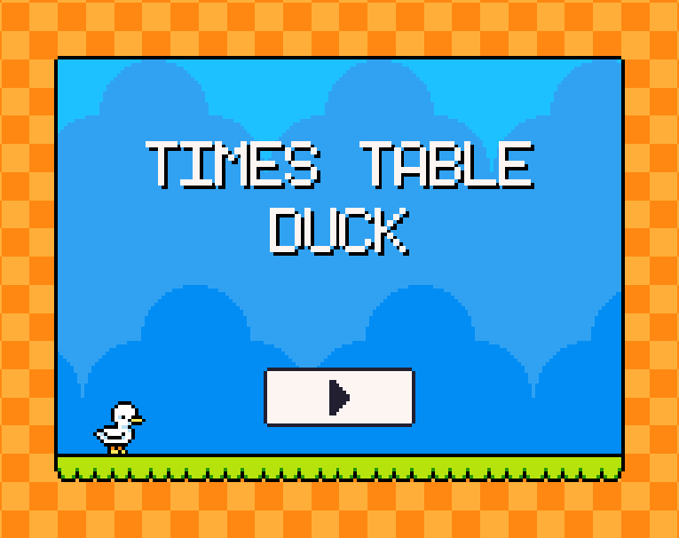

Times Table Duck has a simple menu screen that allows the user to start the game and shows the title and the player character. The art style of this game is plain, with its pixelated graphics, which means that the user can see simply the elements of the game that need to be interacted with and used to complete the tasks.

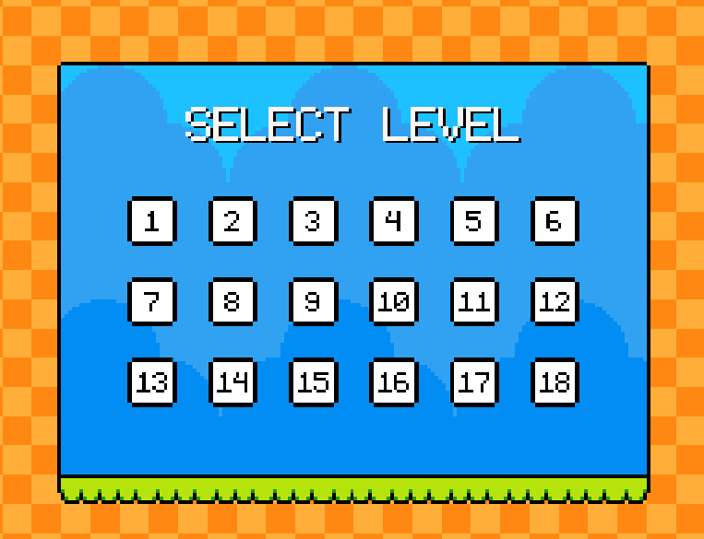

A select level screen allows the user to see how many levels there are and then later lets the user choose whichever level they want once they have completed it. This select screen is simple and easy, allowing the user to easily choose what level they would like to replay. The large number of levels also increases the ability to replay many times.

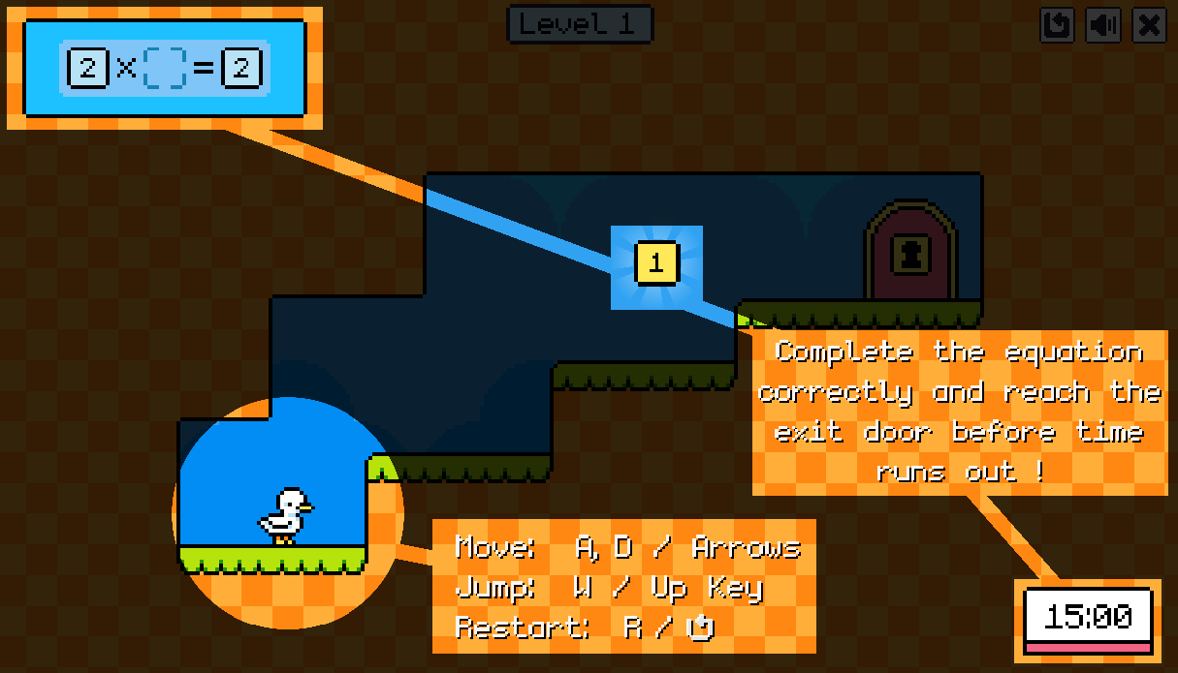

The instruction screen is simplistic, highlighting the important game objects and explaining quickly how the game works. It simply highlights the component and describes them simply to allow the reader to see how each part works. The timer in the bottom corner is easily visible, as well as the problems that need to be solved in the top left corner. The character stands out compared to the environment as there are no other white objects and so do the numbers that need to be collected as they are a bright yellow.

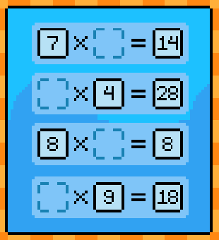

As you progress, the game gets more difficult. More problems are added, meaning you have to collect more numbers in the same time limit. The game also adds spikes, moving spike enemies, and falling spikes to each level as you go on. This adds a lot of difficulty to the game, making it more interesting to play as it isn’t just the simple platformer that the first level begins with.

## Hit the Button

[**https//www.topmarks.co.uk/maths-games/hit-the-button**](https://www.topmarks.co.uk/maths-games/hit-the-button)

Hit the button is a simple game that gives the user multiple questions to improve their speed and knowledge retention. It is very repetitive, which is helpful for learning and remembering, but is quite boring when u want to play it for longer than a couple of minutes. I think that this game could be improved by adding more engaging and interesting gameplay.

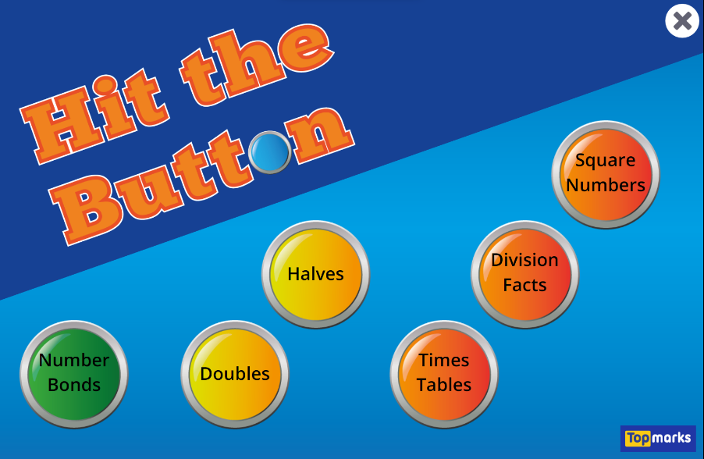

The start screen provides a simple introduction to the game, showing its title and the options that the game has. It allows the user to select the choose the subject that they would like, bringing them to a second screen with further choices. This screen is effective and very easy to understand and use.

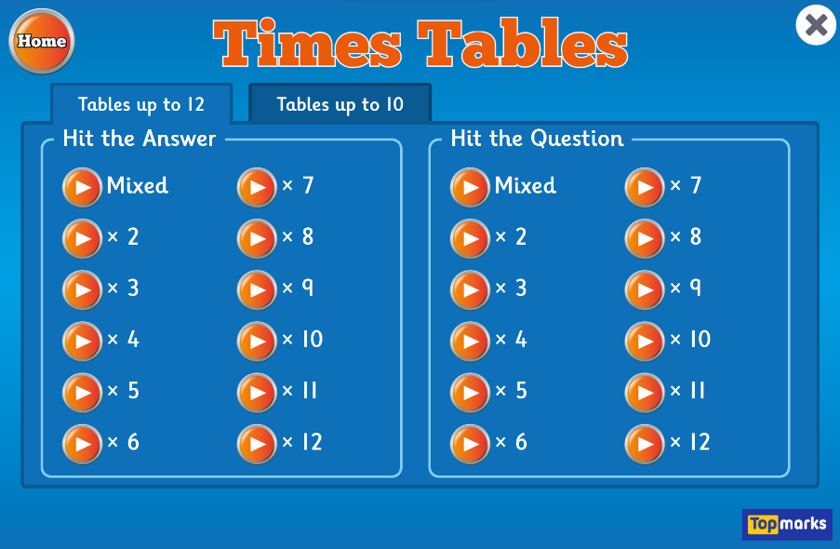

The screen that you are taken to when a button is clicked provides a wealth of options, allowing the user to choose almost anything they need. The options allow great customisation, allowing the user to choose which times tables they’d like to do and even choose between whether they would like to answer a question or get an answer and provide the question.

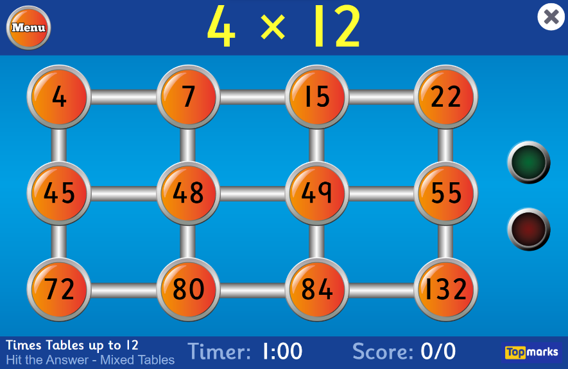

The question screen gives the user a large question at the top and then shows the answer choices in the middle of the screen. On the right, the green and red lights show if the answer is correct or not and at the bottom of the screen there is a timer and a score counter so that the user can easily see how long they have left and what their current score is. If the user gets the question wrong, then it is repeated to allow the user to get the question correct before moving on.

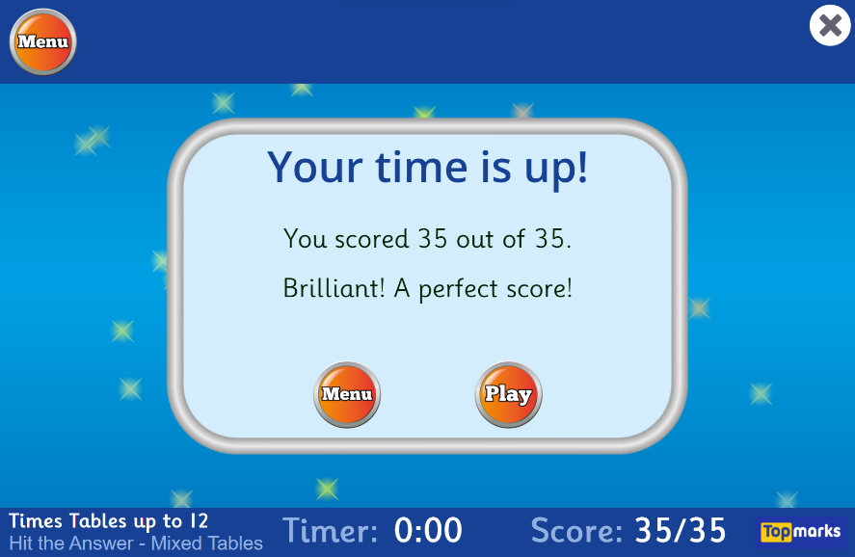

After the time is up, the game displays your score and displays a comment about how well you did. It also shows a button to allow the user to return to the menu or play the same mode again. This screen is quite minimal and simple allowing for the user to easily see how well they did but could perhaps be improved with some more complex analysis of how the user got on.

## Super Mario Bros

Super Mario Bros. is a classic, retro platformer game that is one of the first scrolling platformer games that were created, allowing the user to move around the environment freely by jumping and running. This game has almost no educational aspects, but is a great example of a platformer game, with elements that would be beneficial to add to my game. It has a pixelated style with bright colours that interest and engage the user.

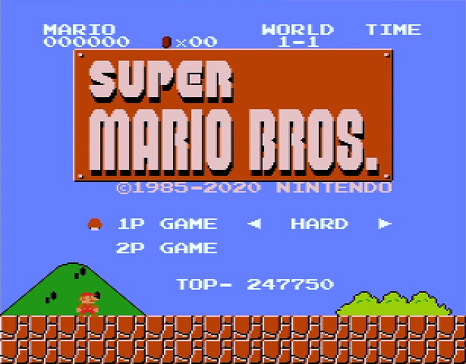

The title screen is incredibly simple, with only a couple of options. This screen allows the user(s) to choose between one or two player gameplay and then choose the difficulty of them. This allows the user to tailor the game to their own abilities based on how good they think they are. This screen also shows the level (world) which the user is currently in and shows a high score at the bottom, which pushes the user to do better than before.

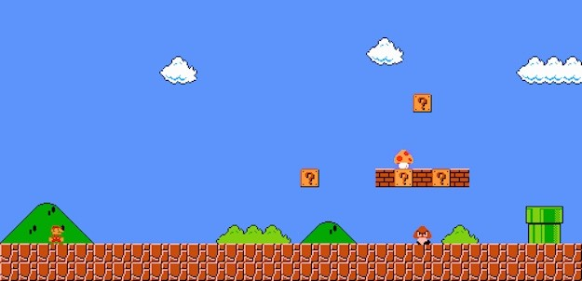

The beginning of the first level introduces the user to many of the games core mechanics, such as jumping, opening the question mark blocks, killing enemies and getting power-ups. Even without a tutorial, which the game lacks, the user is directed to these facts by the design of the level and its graphics, allowing them to easily work out for themselves what they should be doing.



Super Mario Bros. has several power ups that the user can collect. This gives an added depth to the game and makes it more fun for the user, allowing them to play for longer as the power ups make it easier for them to survive. It also increases the replay-ability as they can attempt to get the power ups in each level. The power ups also change the appearance of Mario, making him bigger or giving him a different outfit to denote the fact that he’s in possession of a power up.

Reusable features

|  |  |
| --- | --- |
| REUSABLE FEATURES | JUSTIFICATION |
| Front-end menu (topic, learning or practicing, difficulty) | A menu is needed to allow the user to interact with the game, letting them choose the topic and difficulty of the learning that they would like to do. |
| Bright colours | The game will use bright colours to engage the user and entice them to interact with the game, grabbing the user’s attention and allowing them to easily identify the different parts of the game. |
| Characters | A character can be used to allow the user to interact with and relate to the game. The user will be able to control the character to move and jump freely to traverse the environments while solving the problems. |
| Levels | Different levels could allow for a variety of scenarios, meaning that the user will stay engaged for longer if the scene changes regularly, instead of just staying the same for each topic or difficulty that they do. It also allows for a variety of difficulties to allow the user to tailor the game to themselves. |
| Score | A score will allow the user to track their progress and see how well they are doing during the game. It also allows the user to have something to aim for when they are playing. |
| Timer | Using a timer gives a challenge to the user, meaning that they have to know what they’re doing to be able to complete the questions/levels in time. This also pushes the user to do better than last time and complete the levels quicker. |
| Visual way of seeing correct/incorrect answers | This allows the user to get immediate visual feedback of how they are doing in the game, allowing them to see if their understanding is at the level that they think it is or if they need to try harder to understand the questions while doing them. |

My current ideas which may help to solve the problem

* The game could involve a question at the top of the screen, like in Hit the Button, and answers scattered around the level, like in Times Table Duck, that the user has to collect to gain points or power ups.
* To finish the level, the user could be required to answer a more complicated question or quiz that they need to type the solution to.
* Similar to Hit the Button, the menu screen could include a large number of options, allowing the user to pick different topics. This could then bring them to a screen where they choose whether they would like to see the notes on a topic to learn it or a level in which they can attempt to answer the questions to practice it.
* The environment should be simple, to make the main focus of the game answering questions, without the user needing to spend too much time trying to find their way around the level, but it could still contain a few puzzles to challenge the user.
* Maybe as the difficulty of the topic increases, the complexity of the level increases with it or the user could have a separate level difficulty slider, like in Super Mario Bros, which could allow them to change the topic and level difficulty independently.
* The tutorial could be in the style of Times Table Duck, referencing each element as it is introduced to allow the user to quickly and easily understand how to complete the levels.
* There could be a way to set work to complete in class or as homework, with the results being relayed back to the teacher (although this may be too complex for this project).
* An achievement system for each level could be created to track student progress (if the students and teachers say that this is wanted).
* A character picker could also be added to allow more customisation for the user (again, if wanted by students and teachers).
* The solution will need to keep a good balance between learning and fun, so that it is beneficial for the students to be using, without just acting as a game they can play in class for fun, for example, all levels will have a set number of questions no matter the difficulty).
* The learning parts could be levels that the user has to run through, with graphics teaching them concepts as they go and showing them how to do questions before giving them a few practice questions to try.

Interview details

## Teachers

I will interview the teachers to gain an idea of how the game could be structured to benefit them and assist in teaching in lessons. It will also allow me to find the exact user requirements for the teachers and give me a good idea of the student’s needs as their answers may be less advanced and specific compared to the teachers’ responses. Conducting an in-person interview is beneficial when asking the teachers as it allows me to ask for further detail if needed from the teachers and gain a greater understanding of the problems that need to be solved, however it has drawbacks, such as the fact that I have to schedule a time to ensure that I will be able to see the teachers.

The questions are as follows:

1. What are the issues with the current games or online resources?
2. What would you like to change to fix these problems?
3. What parts of the games that you currently use would you like to see in a solution?
4. What features of a game keep students engaged the best?
   * What sort of colours/fonts?
   * What type of characters are most appealing?
   * What controls are easiest to understand for the children?
5. How do you think concepts could be best visualised/portrayed for the best student understanding?
6. Would an achievement system/progress tracker help to engage the children more in their playing and learning?
7. How could a rewards system be structured, perhaps linking to the school’s reward system?
8. Do you think a learning feature would be beneficial for the students? (Hints, examples, tutorials, etc.)
9. What topics would be the most valuable to make first in the game?

Questions 1 – 3 will allow me to gather some information on how to make the game a better alternative to the current products and fix the issues in these solutions that already exist.

Question 4 and 5 will give me an idea of the design requirements for the user to allow me to create a game that is appealing, interesting and easy for the students to understand and play and make them want to replay.

Question 6 and 7 will show me what I can add to the game to make it rewarding for the students, again adding to replayability, and making the game a lot more engaging for the users.

Question 8 will help me to decide whether a feature that allows the students to learn the topics or if I should simply add small hints and examples.

Question 9 will let me work on the topics that are most important first so that it can be tested with these topics before I try to make a large number of topics.

## Students

I am going to use a form to collect the responses from the students so that I can get a response from each class. This should also allow me to have a very good representation of the students, with a lot of data to allowing me to work out the requirements for the students. The benefits include being able to send this form to multiple people to complete and allowing them to complete it in their own time and, since it is an online form, I can receive the data almost instantly after they complete the questionnaire. It does, however, have drawbacks, such as if they are unsure of the questions then I cannot clarify the meaning and it may take a while to complete, meaning I may be waiting on results.

The questions are as follows:

1. What do you like about the games you use in school?
2. What don’t you like about the games you use in school?
3. What character would you like to play as while learning?
4. Would you like multiple characters that you can play as?
5. Do you like getting achievements when you play games? (e.g. trophies)
6. Do you want to learn in the game or just practice questions?
7. What topics would you like to be able to learn in this game?

Question 1 and 2 will give me a good idea of the features that the students want for the game, allowing me to make specific user requirements to tailor it to the students’ wants and needs.

Question 3 will give me a list of characters that I can add to the game to allow the students to have customisation and choice if they would like it.

Question 4 will let me judge whether the students would like achievements to reward them for the work that they do or if it would not be needed to keep the students engaged.

After talking to one of the teachers, we decided that question 5 was too hard to understand without explaining trying to explain the whole idea for the game, so I have removed it from the students’ questions and will just ask the teachers as I can spend time with them to make sure they fully understand what I am asking.

Question 6 will show me what topics are required most by the students so that I know which topics to add to the games and which ones perhaps don’t need to be made if there is no interest in them.

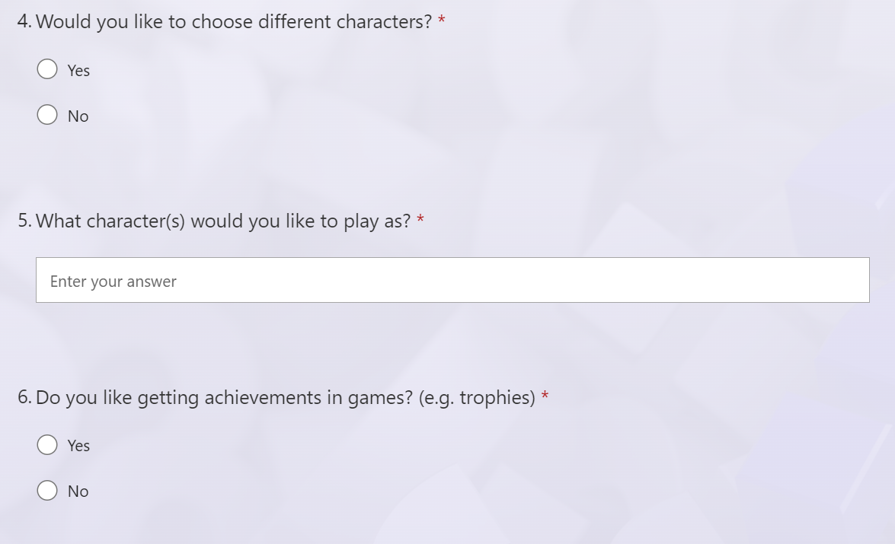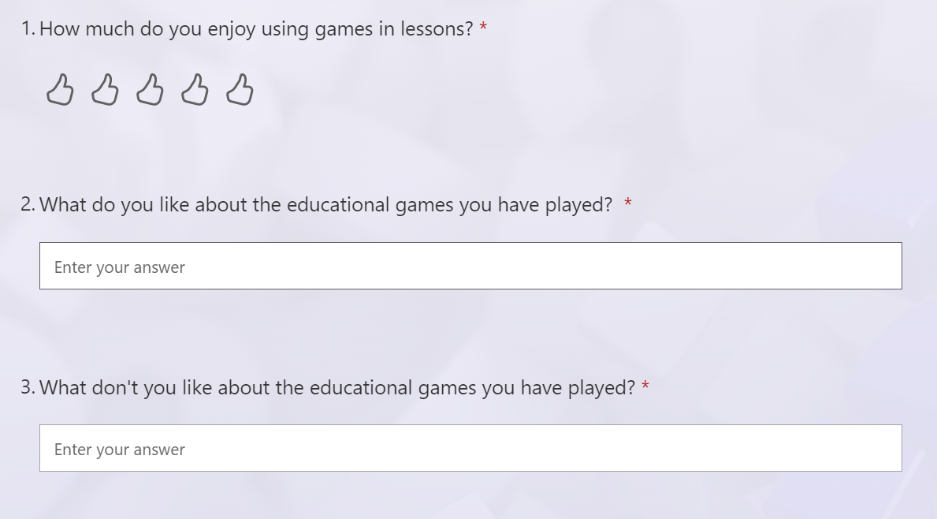

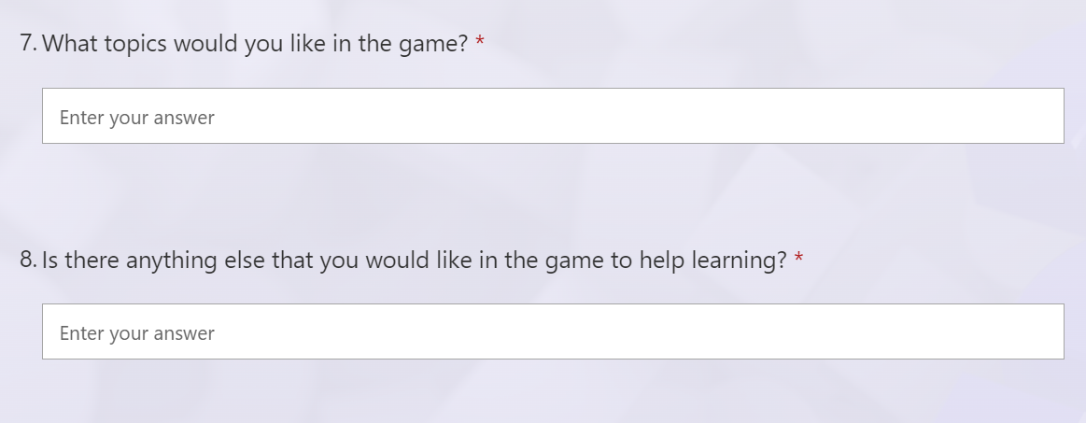

Interview question answers

## Teachers

1. **What are the issues with the current games or online resources?**

* Good ones are paid for or need an email address to log in which makes it difficult in a primary school environment.

1. **What would you like to change to fix these problems?**

* Have a centralised teacher login where teachers can set up passwords and accounts for the pupils that the teachers can use to check the progress of the children.

1. **What parts of the games that you currently use would you like to see in a solution?**

* Bright
* Interactive
* Children are happy to play them despite the fact that they are educational.

1. **What parts would you remove/improve in the solution?**

* It would be nice to see the game progress as the children progressed so that the children couldn’t take the easy option each time that they play.

1. **What features of a game keep students engaged the best?**

* They enjoy games with an adventure aspect, like escaping sharks or running from lines and answering questions to help them to do this.
  + **What sort of colours/fonts?**
    - Games with big fonts and bright colours and pictures keep them the most interested.
  + **What type of characters are most appealing?**
* Girls seem to like games with unicorns/horses and such.
* Boys like games with cars and sharks and dragons, etc.
  + **What controls are easiest to understand for the children?**
* Arrow keys and space bar.
* Clicking with the mouse.

1. **How do you think concepts could be best visualised/portrayed for the best student understanding?**

* Speech bubbles, cartoon characters explaining and doing, like tutorial levels on most video games.
* Not too much text and writing – more pictures/videos

1. **Would an achievement system/progress tracker help to engage the children more in their playing and learning?**

* Yes, they like earning rewards such as badges, merits, certificates.

1. **How could a rewards system be structured, perhaps linking to the school’s reward system?**

* If teachers could have access to the progress, specific amounts of progress could be related to the school’s house points.
* Certificates could be given out (easy to print out) for completing levels to reward the students for their progress.

1. **Do you think a learning feature would be beneficial for the students? (Hints, examples, tutorials, etc.)**

* If a section could be created that would have for example a sprite that gives you hints or examples instead of just having questions, then that would be beneficial for the students.
* Tutorials would be good to have on each topic anyway, without a specific learning feature, just a tutorial before doing the questions.

1. **What topics would be the most valuable to make first in the game?**

* Times tables
* Place value (units, 10s, 100s)
* Time would be very useful, but it is a confusing topic to teach.

## Students

1. **What do you like about the games you use in school?**

* They help us learn, if you get good at them, they get easier. You can play the game and learn at the same time. Being able to choose your level.
* They are fun and they also teach us things. Help us to learn from mistakes.
* Fun to play, memorable, enjoy while learning, helpful to remember things, helps to repeat the skill.

1. **What don’t you like about the games you use in school?**

* Sometimes the questions are too hard, and you get muddled up. If the questions are too hard it stops being fun.
* Too many adverts. Cost money. If you are stuck on a question and you don't know what to do. Sometimes too easy. Not enough storage space. Passwords needed. Can be a bit boring. Never end and give harder and harder questions.
* Can be childish. Too narrow a focus and repetitive. Too focused on the work. Too time pressured. Need different levels of challenge.

1. **What characters would you like to play as while learning?**

* Unicorn, Among Us characters, dog, Roblox character, princess, Fortnite character, Disney characters (Stitch), Footballers, Myself and my friends/family, Pilot, panther, Minecraft characters, bunny, hamster, Cocomelon, horses.
* Animals. Mario characters. WWE wrestlers. Avengers or DC characters. Play as yourself. Cavemen/women. Cuphead character. Apex legends. Godzilla. King Kong.
* Animals theme, Maths legends of the past, Avatars of yourself, Dinosaurs, Cartoons, Customised characters.

1. **Do you like getting achievements when you play games? (e.g. trophies)**

* Yes
* Yes
* Yes

1. **What topics would you like in the game?**

* Percentages, time, BIDMAS, different topics for different levels, four operations, fractions.

1. **Is there anything else that you would like in the game to help learning?**

* Game hints, answer boxes, no adverts, if you don't know a question a button tells you how to work it out.
* Tutorials, puzzles, hints, characters that come and help you, revision at the end of each level, YouTube/video guides.
* Difficulty levels at the start, help or hint button, cosmetics for your character to unlock, lots of levels in tiers, reward for going back on the game, features of classic games, e.g. Monopoly.

Having received the results, I realised that I didn’t specify that the game will be focused on maths, so many of the answers for the topics involve things such as animals, dinosaurs, superheroes etc. This shows one of the drawbacks of using a questionnaire as I was not able to clarify this while it was being answered, meaning that I now have answers that are irrelevant to my game, so instead I will just use the topics suggested by the teachers and any maths related topics that were suggested in the questionnaire. These answers could also be used in the future to expand the game and add topics outside of maths.

Essential features

These are features that are vital to the solution. They are necessary to make a game of this type or have been specified by the stakeholders as required for this solution.

|  |  |
| --- | --- |
| FEATURE | EXPLANATION |
| Menu screen | The menu screen will introduce the game and allow the user to navigate through the options. The menu screen will allow the user to login, then choose the topic that they would like to practice. The menu screen should be very easy to move through and understand so that the students can use the game without needing to be told how to. |
| Appealing design | The design of the game should be appealing to the users, using bright colours, large fonts, and a simple style. This will allow the students to understand the game more easily as the important points can be made very obvious and the game will also be interesting and engaging for the users due to the design, enhancing the replayability of the game. |
| Maths questions | As learning is the focus of the game, the maths questions will appear at certain points in the game, requiring the user to answer them before they can continue. This will mean that the user will be engaged in the game, while also learning intermittently throughout playing. |
| Short form inputs | Due to the style of the game, the inputs must be very simple as they will need to be entered quickly. This means that the questions can only have either short text/numerical answers or clickable choices, so the questions must be structured carefully so that the answers can be input easily by the users. |
| Different logins | The students should have a login to allow the individual data to be sent to the teacher and to allow them to have a personalised experience. This could also be used to allow the students and teacher to be taken to different screens when entering the game. |
| Player movement | The player will be able to move around to interact with the environment and find questions to answer to complete the level. The game will be made as a platformer, meaning the user can move left and right and also jump to clear obstacles and move to the places that they need to be to progress. |
| Data to the teacher | Data will be sent to the teacher for each student to allow the teacher to see the progress of the students and assign them work based on how they’re doing. This is beneficial to the students as they can have work tailored to them specifically so that they can progress, and it is beneficial to the teacher as they can see which students need more help on specific topics. |
| Different topics | The game must have at least a few different topics so that the user stays engaged and can choose to practice topics that they struggle with. This will also allow the game to be replayed many times with different topics as it will be interesting each time due to the changed focus. The topics will all be quite simple so that they can be implemented into the game easily, but there will be multiple to choose from when starting the game. |
| Tutorials and hints | To allow the students to understand the game, without having to be shown by the teacher, a tutorial could be used to introduce the game. Hints would also be added, as requested by the stakeholders, to help the students understanding of the topics whilst they are playing the game and allow them to keep playing, or replay, if they don’t understand a topic to improve their knowledge. This can be implemented in multiple different ways, showing up if they take too long or if they get a question wrong for example. |
| Answer validation | The game must show whether the user input the correct answer, as it will allow them to see how they are doing during the game. This will engage the user as it will motivate them to get the answers correct and will increase the replayability` of the game as the students will attempt to get more answers correct each time. |
| Scoring | A scoring system will also be required for the students, and teachers, to see how they are progressing. The scores can be based on whether the answers are correct or incorrect and how long the user took to get the answer. This data will be used to show the student how they did on the level, a higher score meaning they have done better. |

Desirable features

These are features that I would like to add if it is possible. These will be added if I have time, or if they turn out to be easier to add than expected. Some of these features had been requested by the stakeholders, which would be nice to add, however they are not essential to the purpose of this solution.

|  |  |
| --- | --- |
| FEATURE | EXPLANATION |
| More complex topics | I would like the game to cover more complex topics, up to secondary school level and maybe even GCSE and A level, as this could be a very effective way to revise, however these topics would be too complex to explain and enter into the game and would also not be required for my stakeholders. |
| Personalised questions | If the questions were able to change and adapt depending on how the user was doing this would be very useful and engaging for learning, however this may be complicated to implement and may not be helpful as the questions should probably be of the same difficulty. |
| Homework setting | I would also like for the teacher to be able to set homework for classes and individual students to allow them to interact directly with their students through the game, but it is not a feature that was requested by the stakeholders. |
| Different characters | Different characters could be a fun and interesting feature that would engage the students and interest them, meaning they will replay the game; however, it is not needed for the purpose of the solution and may be difficult to include as it would include making lots of characters and adding those to the game as changeable and playable avatars. |
| Timer | The game could include a timer to engage the users and interest them. This was not requested by the stakeholders and is not required for the solution to function as intending, but it could be an option that would engage the user and add replayability to the games. |
| Enemies | To make the game more interesting, enemy characters could be added, like in Times Table Duck and Super Mario Bros. This could allow for more problem-solving capabilities in the game and increase the engagement and replayability, but it is not required for the solution to fit the purpose and was not requested in the interview stage. |
| Archive/save data for next year | The data that is sent to the teacher could be saved so that the teacher of those students next year could easily access the data. This could be incredibly convenient for the users as it would mean that teachers won’t have to send large amounts of students’ personal data to one another. |
| Data shared with other teachers | If the teacher is able to access multiple classes’ information, this would be very useful. It could allow teachers to see how their class compares to other classes and also allow teachers to cover lessons without having to ask students what they are currently learning, they could simply access the students’ data from the game. |
| Security | A hashing algorithm could be used to ensure that the passwords that are entered by the user are not accessible to anyone and are therefore stored securely. This will mean that accounts cannot be accessed by anyone other than the user who owns that account. |
| Achievements | Achievements would engage the user more as it will give them an incentive to work towards. This should increase interest in the game and increase the replayability of the game as the user can attempt to gain as many achievements as possible, however this is not necessary for the game to function in the intended way. |

Limitations of solution

The limitations of the solution are the features that are not possible to add for specified reasons. Identifying these before beginning to develop the solution will allow me to focus on the features that can be made, instead of getting stuck on features that are unachievable.

|  |  |  |
| --- | --- | --- |
| LIMITATION | JUSTIFICATION | WHY IS THIS A LIMITATION? |
| Detailed graphics | More detailed graphics will allow the game to be more complex and allow users to see features more easily due to the greater detail. | This is a limitation due to the fact that many computers at schools are not very powerful and would be unable to render complex graphics. |
| Complex menu options/settings | Having a wealth of options will allow the user to tailor the game to their way of play, allowing the users to enjoy and engage more with the game. | This will be difficult to understand due to the game being aimed at primary school children, meaning that the options must be kept as simple and minimalistic as possible. |
| Online games | An online mode would be a good way to interest the students and engage them through competition. This could be used to test the students, or just for a fun challenge. | I will likely be unable to use multiple computers to create and test a feature like this. This would also create more limitations relating to internet speeds and connection between computers that could be incredibly difficult to solve in relation to my proposed solution. |
| Data saving | It would be incredibly useful if the student data could be saved to the school’s data systems, meaning that it could be accessed by and teacher whenever it is needed. | I will not be able to access the data systems of the school, so I would not be able to add this feature when making my game. |
| Data analysis | The data sent to the teacher could be analysed to allow the teacher to easily see how students are doing individually and how the class are doing. | The analysis of the data may be quite complex and difficult to understand. It may also take time to develop and update the analysis, not showing much when there is not lots of data. |
| Data presentation | The data that has been collected could also be presented instead of simply being in a table, for example using graphs to show students’ progress and class averages. | When data is presented, it will need to be done automatically. This could result in mistakes and confusing results due to the computer’s automation. |
| Data protection act | Due to personal information being entered, the game must adhere to the data protection act. The data protection act means that the data must be handled securely and protected, which may be very difficult to achieve. | This means that the data that is entered should not be actual student data as this would not follow the data protection act. This means that data will have to be created to act as a student, which will take time to ensure that it is similar to real student data. |

Hardware and software requirements

## Hardware

Since the school has both Windows PCs and chrome books, the game should be able to run on both and therefore, based on the computers that they have, the hardware requirements should be as follows:

|  |  |
| --- | --- |
| REQUIREMENT | JUSTIFICATION |
| Monitor | Allows the user to see and play the game. |
| Keyboard | Is used to login and to enter the answers to game’s questions. |
| Mouse | Allows the user to navigate the menu of the game and enter answers. |
| Up to 1GB of HDD/SSD space | Average Unity 2D games are much less than one gigabyte, meaning a small game such as this should require less than 1GB. |
| 1 GHz CPU | Unity specifies a “x64 architecture with SSE2 instruction set support”, which can be any CPU from up to 20 years ago to today. Most CPUs nowadays have a much higher clock speed than 1 GHz, so I will specify this as my requirement. |
| 2 GB of RAM | A 2D game produced on Unity is able to run with very little RAM, meaning that 2GB of RAM will be enough to run the game. Modern computers will have a lot more than 2GB of RAM. |

The specifications of the hardware that the school has are as follows:

**PC**

* CPU – Intel Core i5 (3rd Gen)
* RAM – 4GB/8GB DDR3
* HDD – 120GB
* Monitor – 17”
* Keyboard and touchpad

**CHROME BOOK**

* CPU – Intel Celeron processor (1.1 to 2.6 GHz)
* Graphics – Intel UHD integrated graphics
* RAM – 4GB DDR4
* SSD – 32GB eMMC
* Display – 11.6” HD LED
* Keyboard and touchpad

The school’s hardware therefore exceeds the minimum requirements, meaning that the game should easily be able to run on these computers.

## Software

For Unity games, the game is compiled and creates an executable file. This means that there is only a small amount of software that is required to be able to run the file. This minimum software requirement for running the file on Windows PCs and chrome books are:

**OPERATING SYSTEM**

* Windows 7 or newer
* Chrome OS version R89 or newer

**WEBGL**

* Any recent desktop version of Chrome, Edge, Safari, or Firefox

Success criteria

|  |  |  |  |
| --- | --- | --- | --- |
| REQUIREMENT | EXPLANATION | HOW TO EVIDENCE | REFERENCE |
| Start-up screen | This screen introduces the game to the user, showing them what game they are going to play. | A screenshot that clearly displays the title and a button to take the user to the login screen. | A feature in Times Table Duck and many other games. |
| Login screen | The login screen allows the user to enter their details and login to their specific account. If a correct account is entered, then the user will enter the game. If incorrect details are entered, then the user will need to re-enter their username and password. | A screenshot with the login screen that will have boxes to enter a username and a password and a button to log the user in and screenshots of the code that allows the login to work. | Interview with the teachers |
| Options screen | This screen will allow the user to choose whether they would like to play the game or look at other things such as tutorials. | A screenshot of the screen, showing multiple buttons and the code to allow the buttons to function. | A feature in Hit the Button |
| Multiple topic choices | Multiple topics will be able to be chosen, providing the user with different questions when the user enters the game. | A screenshot of the different topics for the user to choose from. | Interview with the teachers |
| Tutorials | The user will have access to tutorials, explaining how to use different aspects of the game | A screenshot of the different tutorials. | Interview with the teachers |
| Hints | The user should be provided with hints, either when they take too long to work out a question or when they press a button. | A screenshot of a hint button or code to activate a hint after a certain period of time. | Interview with the teachers |
| Large fonts | Large fonts ensure that the game is readable and easy to understand for the students. | A screenshot of the text used in the game. | Interview with the teachers. |
| Colourful text and images | This will ensure that the game is engaging for the user. | A screenshot of the game’s screens. | Interview with the teachers and a feature in the games that were researched. |
| Minimal text | Using less text will make the game easier for the users to understand as there is less to read. | A screenshot of text used in the game. | Interview with the teachers. |
| Maths questions | The questions will be at intervals in the game, requiring the user to complete them before progressing through the level. | A screenshot of the questions and the code used to display and interact with the questions | Feature in Times Table Duck and Hit the Button. |
| Short form inputs | The user will interact with the questions in short form inputs, such as simple numerical questions, to ensure that it is quick and engaging. | Examples of the questions used that are structured to allow for short form inputs to be used. | Interview with the teachers. |
| Level/environment design | The environments that the user will move through must be created to allow the user to interact with and progress through the level. | A screenshot of the design of environments and the code used to allow the player character to interact with the environment. | Feature in Times Table Duck and Super Mario Bros. |
| Different logins | The game requires different logins to allow users to have separate progress. | The code used to allow users to login with different details, resulting in a different account being used. | Interview with the teachers. |
| Player movement | The player character must be able to move around the level to allow the user to progress through the level to more questions. | The code used to allow the player to move around in the game. | A feature of Times Table Duck and Super Mario Bros. |
| Data sent to teachers | The data that is produced by the students must be sent to teachers using a database, a spreadsheet, or a text document. | The code used to produce the data and a screenshot of the data that has been created. | Interview with the teachers. |
| Answer validation/  confirmation | When the user answers the question, there will be a visual showing whether they were correct or not, such as a green light for correct and a red light for incorrect. | The code created to make this happen and a screenshot of it working. | A feature in Hit the Button. |
| Scoring | The user will gain a score while playing the game, showing how many answers they got correct or wrong. | The code used to increase or decrease a score. | A feature in Hit the Button and Super Mario Bros. |
| Score and answers shown at the end of the game | When the user completes the topic, they will be presented with a screen showing their scores and answers that they got correct and incorrect. | A screenshot of the end screen and the code created to produce this. | A feature in Hit the Button. |

# B. Design

Systems diagram

**EXPLAIN THIS DIAGRAM**

|  |  |  |  |
| --- | --- | --- | --- |
| DECOMPOSITION | | | EXPLANATION |
| Intro screen | Login screen | Username and password input | The username and password should be able to be input and verified to ensure that the user can enter their specific account |
| Log in | A button will allow the user to log in after entering their username and password |
| Options screen | Topics button | The topics button will take the user to the topics screen |
| Tutorials button | The tutorials button will take the user to the tutorials screen |
| Main Game | Topics | Option buttons | The different topic options will be displayed on the screen after the user clicks the topics button, giving them the choice of topic to enter into |
| Explanations | A short explanation of each topic will be provided |
| Questions | Appear at intervals during the game | The questions will show up at points in the game, requiring the user to answer them before continuing |
| Player inputs in a short form | A short form input is required for the user to enter the answers quickly |
| Player movement | Player can move and jump around the level | The player should be able to freely move around the level, able to move left and right and also jump to traverse the environment |
| Levels | Players can interact with the level | The player should be able to interact with the objects in the level to be able to move around |
| Designed to interest the user, but easily understandable | The level should be interesting in design but not too complex so that the user can easily move around and understand what they need to do |
| Scoring | Each question gives the user a number of points | The user should be rewarded with points when they correctly answer a question during the game |
| Points are given based on speed of answer | The points received should be greater when the user answers the question more quickly, gaining less points the longer they take to answer |
| Hints | Pop up when the user takes too long to answer | Hints should appear if the user is struggling with the question, meaning they will appear after a certain amount of time so that the user can understand it and solve the problem |
| Pop up when the user gets a question wrong | If an answer is incorrect, then the user will be given a hint so that they can reattempt the question and understand it |
| Tutorials | Options (different topic tutorials) | Question examples | In the tutorials, worked examples will be shown to the user so that they can understand how a question should be solved |
| Topic explanation | An explanation of the topic will also be given to further the user’s understanding and hopefully make the topic easier |
| End of game | Information screen | Displays score | The score will be shown to the user after they finish so that they can see how well they did on the topic questions that they just completed |
| Displays incorrect answers | The questions that they get incorrect should also be shown, so that the user can learn from their mistakes |
| Send data to the teacher | Username | The username will be recorded so that the teacher can know which student produced which result |
| Score | The score will give the teacher a quick idea of how well the student has done on the topic |
| Incorrect answers | The incorrect answers will allow the teachers to see which questions/topics the students struggle with and need to be worked on more |

Why does this approach help to solve the problem?

Using a top-down module design allows me to decompose the problem into small parts. This helps to break down the code, making it easier to tackle the problem as each small module can be coded separately, allowing for a quicker development time and also more specific features can be added to each module. Breaking down the problem this way also involves the computational method of “thinking ahead” as I can begin to work out the inputs and outputs that will be needed for the game to function. This also helps when it comes to coding as it relates to the method of “object-oriented programming” as the solution will be split into objects, which are simply smaller parts of the code that can be reused to reduce development time and hopefully reduce errors in the code. Altogether, this method should allow me to work through the coding of the solution a lot more efficiently and logically.

Screen designs

## Title screen

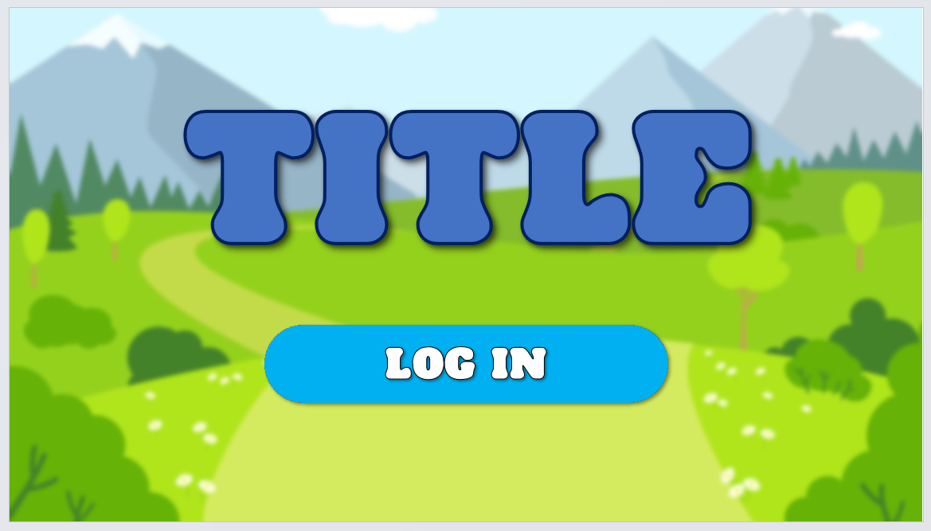

The background for this game is a colourful, cartoon nature scene. This background will interest the user and bring a bright, engaging sense to the game, but is not overcomplicated and confusing, meaning it will not distract the user while they are playing and learning. The text is in a large, bold font that is easy to read and a colour which draws the user’s eyes to it, while the button is even brighter and more enticing, prompting the user to press it to move to the next screen and log in.

**REFER TO SUCCESS CRITERIA**

## A screenshot of a login screen Description automatically generated with medium confidenceLogin screen

The login screen uses the same font and colours, creating a sense of continuity between the screens of the game. This screen is simple, allowing the users to enter their username and password and press the button at the bottom to log in, clearly showing this with the fields labelled Username and Password, and the bright log in button below them.

## A screenshot of a video game Description automatically generated with medium confidenceOptions screen

The options screen has two large buttons, labelled ‘Topics’ and ‘Tutorials’, clearly showing the user the screens that they will be taken to when they press them. It also incorporates a smaller ‘Back’ button, that allows the user to go back to the previous screen, meaning that the user can return to the login screen and login to a different account if they would like to.

## A screenshot of a game Description automatically generated with medium confidenceTopic options

The topics screen allows the user to choose between a number of topics. The topics are simply labelled, so that the user can easily tell which topic is which. This screen also contains a ‘Back’ button, allowing the user to return to the options screen so that they can access the tutorials if they need to.

## A screenshot of a video game Description automatically generated with medium confidenceMain Game

The main game uses the same background to keep it consistent and not confuse the user with a changed backdrop. A bar at the top displays the topic in the middle of the screen, with the score and time on either side. This allows the user to clearly see the score that they are on when answering questions and the time that they have left to complete the level. In the middle of the screen there is a bar with a question mark. When the player touchers this, they will be given a question that they need to complete before progressing to the rest of the level. On the right are the platforms that allow the user to navigate the level and add a sense of interest and fun to the game.

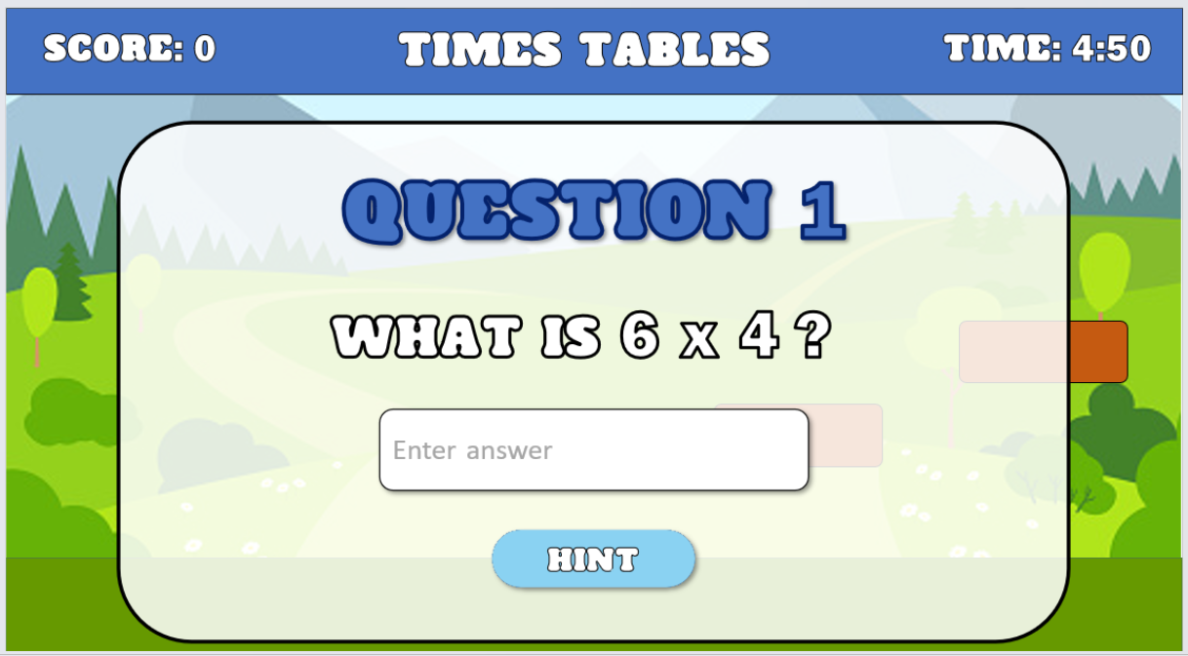When the user is given a question, it will appear over the game screen, allowing the user to still see the game, but the question will take priority, drawing the user’s attention to the question. The screen clearly displays the question number and the question, with a box underneath that the user can enter the answer into. There is also a ‘Hint’ button that will take the user to another screen that can help them with answering the question. If the user answers the question correctly, then the question will disappear, and they will be given a number of points.

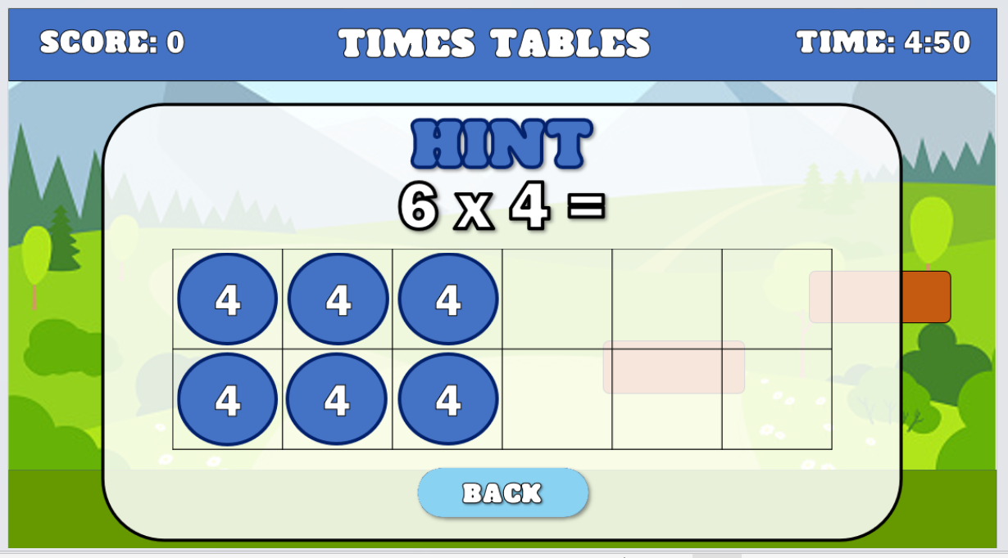The hint screen gives the user a hint that is specific to the question. It will provide the user with a picture or explanation to help them to understand the question and answer it. Once the user has read the hint, there is a back button at the bottom to allow them to return to the question and answer it.

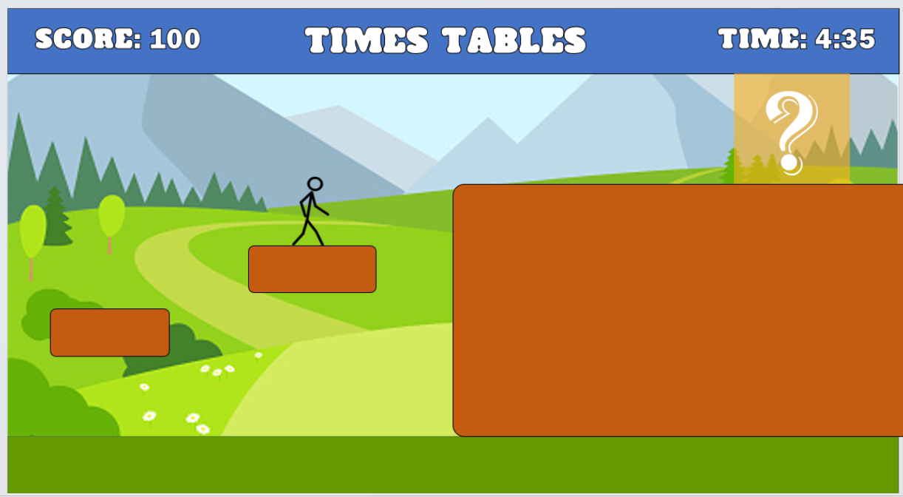This screen demonstrates how the sizes and placements of platforms can differ, and how the questions are affected by this. It also shows how the score increases after answering a question and how the time decreases as the level goes on.

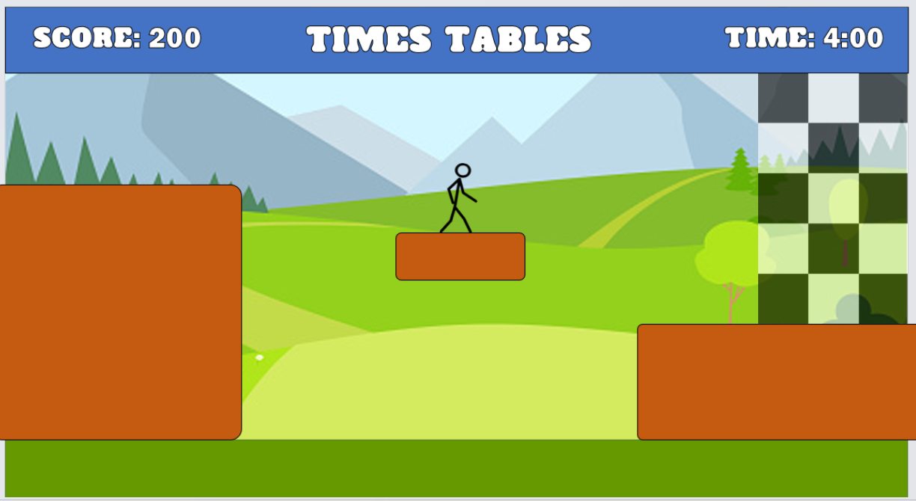

At the end of the level, there is a finish line. When the player reaches this finish line, the level ends and they are taken to the end of game screen, showing how they did on the level.

## End of game screen

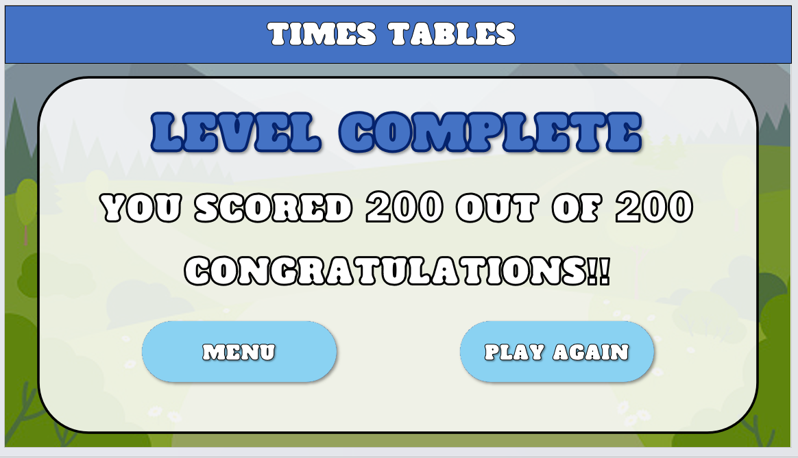

The end of game screen displays ‘Level complete’ at the top, then shows the score that the user has achieved in that level, followed by a short message based on the score that they got. Below are two buttons, ‘Menu’, which will take the user back to the options screen so that they can try another topic or tutorial, and ‘Play again’, which will start the level again so that the user can reattempt it.

## A screenshot of a video game Description automatically generatedTutorial options

Much like the topic options screen, the tutorial options screen has bright buttons, clearly displaying the topic that the tutorial will be about, including a ‘How to play’ button that will show the user how the game is played, including controls and the aim of the game.

## A screenshot of a game Description automatically generated with medium confidenceA screenshot of a video game Description automatically generatedTutorials

The tutorial screens have a simple description of the topics, showing the user information about the topic that should help them to understand how to complete questions based on it. The tutorial screens have the name of the topic at the top, so that the user can easily see which topic they are looking at, and a ‘Back’ button at the button, so that the user can return to the tutorial options screen to look at another tutorial.

## A picture containing text, screenshot, font, number Description automatically generatedData sent to teacher

The screen that the teacher sees simply shows a table containing the students’ names and the scores that each student has achieved in each topic, highlighting the answers in colours on a scale from red to green so that they can easily see at a glance how each student is doing on each topic.

Key variables and structures



|  |  |  |  |  |
| --- | --- | --- | --- | --- |
| METHOD | NAME | DATA TYPE | EXPLANATION | JUSTIFICATION |
| **MENU** | | | | |
| Variable | buttonPressed | Boolean | Allows the game to know if a button has been pressed or not | The game will need to know whether a button has been pressed to be able to run the algorithm associated with that button |
| Function | nextScreen | N/A | Moves the user’s view to the next screen | The user needs to be able to navigate the game screens |
| Function | previousScreen | N/A | Moves the user’s view to the previous screen | The user will need to be able to go to the previous screen, for example when they press the back button on some screens |
| Variable | loginCorrect | Boolean | Returns true or false depending on whether the user has entered the correct login details or not | This allows the game to know whether it should move to the next screen or not |
| Array/  Database | loginDetails | String | Contains the login details for all the users (Username and Password) | This array or database would be accessed to compare to the login details that are inputted and check whether they are correct |
| Text boxes | screenInfo | String | Contains the text for each of the screens of the game | The text boxes will show the user the details of each of the screens to allow them to understand what they are looking at |
| **MAIN GAME** | | | | |
| Sprite | mainCharacter | N/A | Contains the different images that make up the sprite | The sprite will need to be stored and accessed by the game |
| Procedure | jump | Boolean | Allows the user to jump during the main game | The user will need to be able to jump to complete the level and interact with the environment |
| Procedure | horizontalMove | Boolean | Allows the user to move left and right while playing the game | The user will need to be able to move to complete the level and interact with the environment |
| Variable | playerScore | Integer | This will store and track the score of the player throughout the game | The player’s score needs to be kept track of to provide feedback upon completion of the level and to send to the teacher |
| Variable | gameTimer | Float | Represents the countdown of time in the game | Allows the user to see how long is left and will also be able to end the level if the timer reaches 0 without the level being completed |
| Array | questionBank | String | Contains all of the questions and answers needed for each level | Provides a variety of questions that can randomly be accessed by the game, giving some randomness and change to the levels if played multiple times |
| Variable | currentQuestion | String | Stores the current question that is being shown to the player | Keeps track of the current question, allowing for the display and validation of the questions during gameplay |
| Variable | correctAnswer | String | Stores the correct answer for the current question | Allows for the comparison and validation of the player’s answer against the correct answer, allowing points to be added or not depending on whether the answer is correct |
| Array | answeredQuestions | String | Keeps track of the questions that the player has already answered | Allows for tracking and preventing questions being repeated, giving a varied learning experience |
| Array | questionFeedback | String | Stores feedback and explanations related to the questions | Provides additional information or explanations for the player about the question, such as the correct answer, allowing the user to learn and understand better |

Validation rules

|  |  |  |  |  |
| --- | --- | --- | --- | --- |
| VARIABLE NAME | DATA TYPE | VALIDATION NAME | EXPLANATION | JUSTIFICATION |
| playerPosition | Vector | Boundary Check | Prevents the player from leaving the screen or map | Maintains gameplay integrity, prevents unintended consequences, and avoids visual glitches |
| userScore | Array | Character Limit and Type Restriction | Enforces restrictions on the number and type of characters in the user’s score | Ensures readability, prevents visual issues, avoids malicious input, and maintains the integrity of the user’s score |
| characterPosition | Vector | Collision Detection | Validates character movement by detecting collisions with obstacles | Maintains realism, prevents unintended behaviour, and ensures fair gameplay |
| inputScreenButtons | Array | Button Functionality Restriction | Restricts the functionality of buttons on input screens | Maintains control over player interaction, ensures that the user can only press buttons when they appear on the screen |
| playerLogin | String | Length Limit and Required Field | Applies a length limit and makes the name input a required field | Prevents layout issues, ensures necessary information is provided, and promotes saving progress or personalisation |
| playerAnswer | String | Short Answer Validation | Validates the length of the player's answer for short inputs. | Checks if the player's answer meets the minimum length requirement for short answers, ensuring sufficient input and preventing overly brief or incomplete responses. |
| timerExpired | Boolean | Timer Completion | Indicates whether the timer has reached zero, signaling the end of a task. | Allows for checking if the time limit has expired, triggering appropriate actions such as ending the level and moving to the game over screen. It provides a clear indication of time-based completion or failure. |

Designing algorithms

## Flowcharts and pseudocode

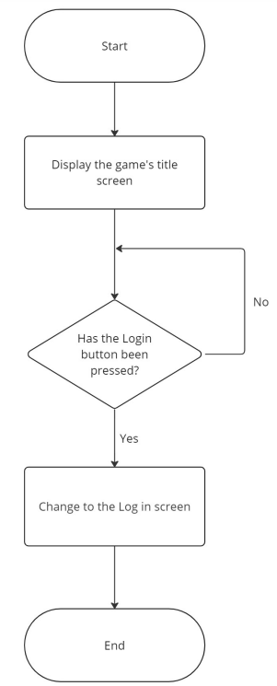**Startup screen**

currentScreen == “Start”

displayStartScreen()

IF loginPressed == True:

DISPLAY(LoginScreen)

currentScreen == “Login”

ENDIF

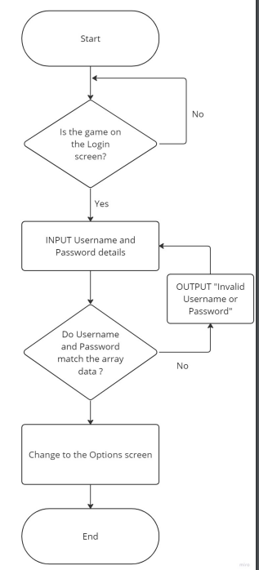**Login screen**

WHILE currentScreen == “Login”:

username = INPUT()

password = INPUT()

IF username == usernames[user] AND password == passwords[user]:

DISPLAY(OptionsScreen)

currentScreen == “Options”

ELSE:

PRINT “Invalid Username or Password”

ENDIF

ENDWHILE

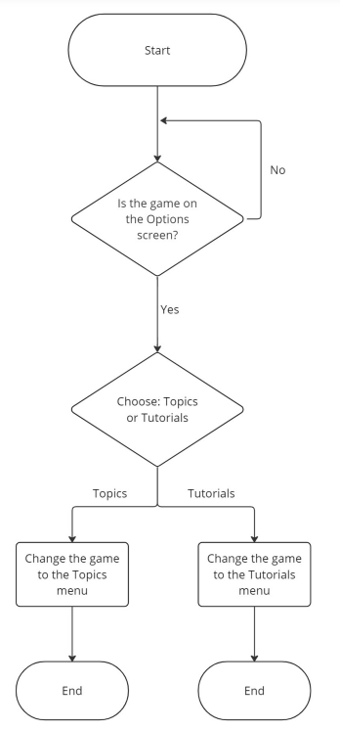**Options screen**

WHILE currentScreen == “Options”

IF topicPressed == True:

DISPLAY(TopicScreen)

currentScreen = “Topics”

ELSE IF tutorialsPressed == True:

DISPLAY(utorialScreen)

currentScreen = “Tutorials”

ENDIF

ENDWHILE

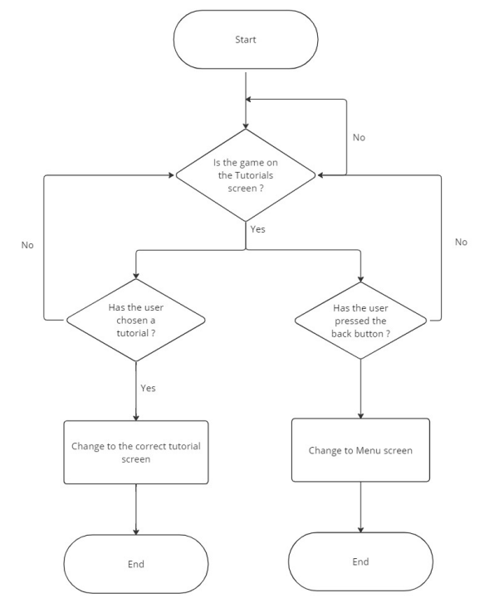**Tutorials options screen**

WHILE currentScreen = “Tutorials”

SWITCH TutorialOptions:

CASE HowToPlayTutoPressed = True:

DISPLAY(HowToPlayTuto)

currentScreen = “HowToPlayTuto”

tutorial = True

CASE TimesTablesTutoPressed = True:

DISPLAY(TimesTablesTuto)

currentScreen = “TimeTablesTuto”

tutorial = True

CASE PlaceValueTutoPressed = True:

DISPLAY(PlaceValueTuto)

currentScreen = “PlaceValueTuto”

tutorial = True

CASE PercentagesTutoPressed = True:

DISPLAY(PercentagesTuto)

currentScreen = “PercentagesTuto”

tutorial = True

CASE BidmasTutoPressed = True:

DISPLAY(BidmasTuto)

currentScreen = “BidmasTuto”

tutorial = True

CASE FractionsTutoPressed = True:

DISPLAY(FractionsTuto)

currentScreen = “FractionsTuto”

tutorial = True

CASE backPressed = True:

DISPLAY(OptionsScreen)

currentScreen = “Options”

DEFAULT:

currentScreen = “Tutorials”

ENDSWITCH

ENDWHILE

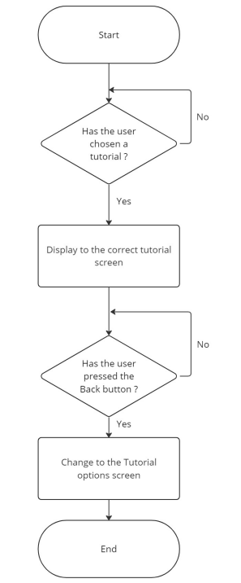**Tutorial screen**

WHILE tutorial == True:

SWITCH Tutorials:

CASE currentScreen = “HowToPlayTuto”:

IF backPressed = True:

DISPLAY(TutorialScreen)

currentScreen = “Tutorials”

tutorial = False

ENDIF

CASE currentScreen = “TimeTablesTuto”:

IF backPressed = True:

DISPLAY(TutorialScreen)

currentScreen = “Tutorials”

tutorial = False

ENDIF

CASE currentScreen = “PlaceValueTuto”:

IF backPressed = True:

DISPLAY(TutorialScreen)

currentScreen = “Tutorials”

tutorial = False

ENDIF

CASE currentScreen = “PercentagesTuto”:

IF backPressed = True:

DISPLAY(TutorialScreen)

currentScreen = “Tutorials”

tutorial = False

ENDIF

CASE currentScreen = “PercentagesTuto”:

IF backPressed = True:

DISPLAY(TutorialScreen)

currentScreen = “Tutorials”

tutorial = False

ENDIF

CASE currentScreen = “BidmasTuto”:

IF backPressed = True:

DISPLAY(TutorialScreen)

currentScreen = “Tutorials”

tutorial = False

ENDIF

CASE BackPressed = True:

DISPLAY(OptionsScreen)

currentScreen = “Tutorials”

tutorial = False

DEFAULT:

Tutorial = True

ENDSWITCH

ENDWHILE

**Topics option screen**

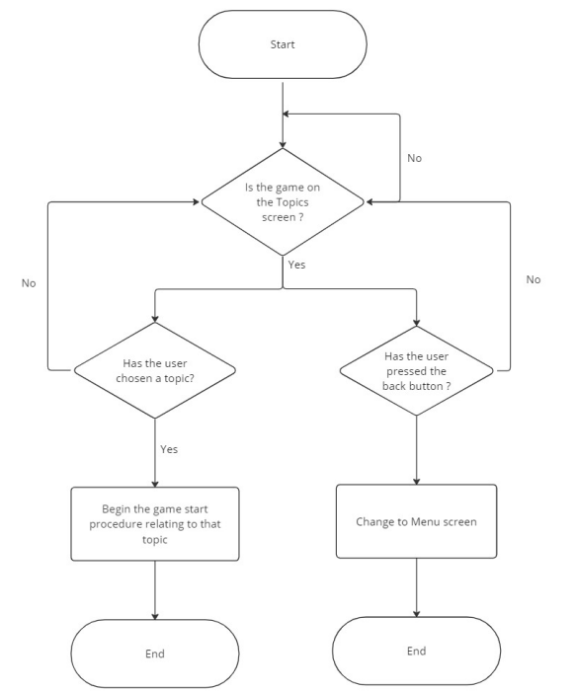WHILE currentScreen = “Topics”

SWITCH TopicOptions:

CASE TimesTablesPressed = True:

startTimesTables()

currentScreen = “TimeTables”

CASE PlaceValueTutoPressed = True:

startPlaceValue()

currentScreen = “PlaceValue”

CASE PercentagesPressed = True:

startPercentages()

currentScreen = “Percentages”

CASE BidmasPressed = True:

startBidmas()

currentScreen = “Bidmas”

CASE FractionsPressed = True:

startFractions()

currentScreen = “Fractions”

CASE TimePressed = True:

startTime()

currentScreen = “Time”

CASE backPressed = True:

displayOptionsScreen()

currentScreen = “Options”

DEFAULT:

currentScreen = “Tutorials”

ENDSWITCH

ENDWHILE

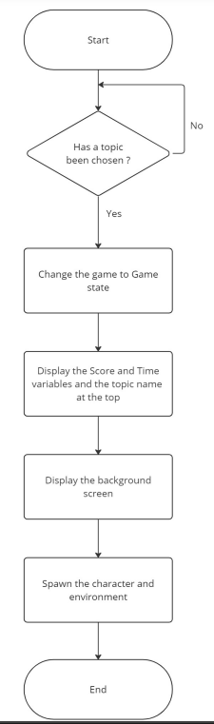**Game start (specific for each different topic)**

characterX = 0

characterY = 0

environment = []

score = 0

time = 300

FUNCTION spawnCharacter(initialX, initialY):

characterX = initialX

characterY = initialY

INSTANTIATE(character, characterX, characterY)

FUNCTION spawnEnvironment(object1, object2, etc)

environment = [object1, object2, etc]

RANDOM.SHUFFLE(environment)

DISPLAY(Score)

DISPLAY(Time)

DISPLAY(Background)

spawnCharacter(user, 100, 200)

spawnEnvironment()

currentScreen = “MainGame”

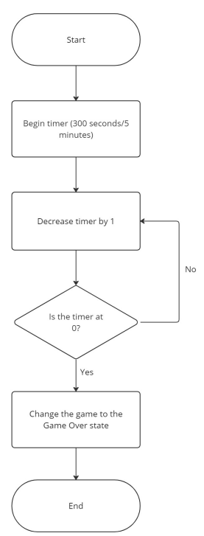**Timer**

FUNCTION gameTimer(length):

timer = length

WHILE time > 0:

timer -= 1

SLEEP(1)

ENDWHILE

DISPLAY(GameOver)

currentScreen = “GameOver”

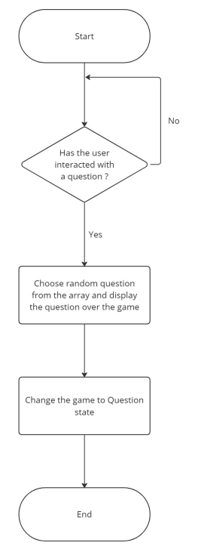**Questions appear**

questions = [[…][…][…]]

FUNCTION chooseQuestion(currentDifficulty):

currentQuestion = [currentDifficulty][RANDOM(LENGTH(questions[currentDifficulty])

# selects a random question from the current difficulty using the number of questions in that sub array

DISPLAY(currentQuestion)

currentScreen = “Question”

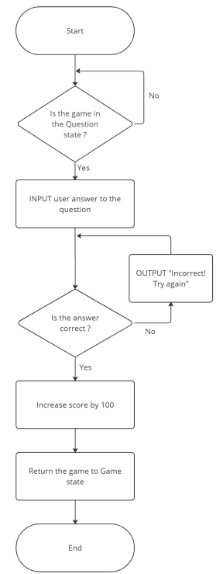**Question answer**

WHILE currentScreen == “Question”:

answer = INPUT()

IF answer == questionAnswers[currentQuestion]:

score += 100

questionCorrect = True

DISPLAY(Background)

currentScreen = “MainGame”

ELSE :

PRINT “Incorrect! Try again”

ENDIF

ENDWHILE

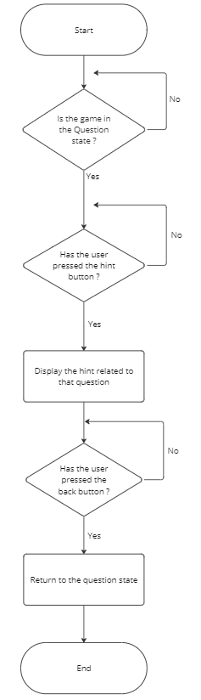**Question hints**

WHILE currentScreen = “Question”:

IF hintPressed == True:

DISPLAY(hint[currentQuestion])

currentScreen = “Hint”

hintUsed = True

ENDIF

WHILE currentScreen == “Hint”:

IF backPressed == True:

DISPLAY(currentQuestion)

currentScreen = “Question”

ENDIF

ENDWHILE

ENDWHILE

**Question difficulty**

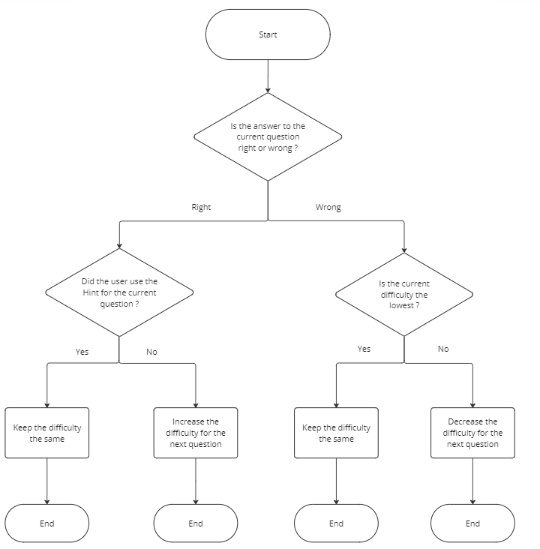

FUNCTION changeDifficulty(currentDifficulty)

prevDifficulty = currentDifficulty

IF questionCorrect == True:

IF hintUsed = True:

currentDifficulty = prevDifficulty

ELSE IF hintUsed = False:

currentDifficulty = prevDifficulty + 1

ENDIF

ELSE:

IF prevDifficulty = 0:

currentDifficulty = prevDifficulty

ELSE IF prevDifficulty > 0:

currentDifficulty = prevDifficulty – 1

ENDIF

ENDIF

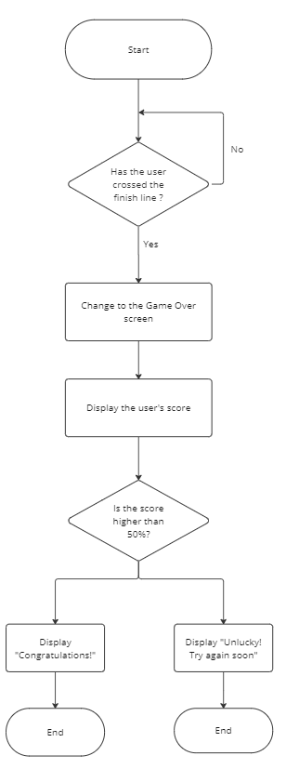**Game finish**

IF finishCrossed == True:

DISPLAY(GameOver)

currentScreen = “GameOver”

PRINT “You got”, score, “out of 1000”

IF score >= 500 :

PRINT “Congratulations”

ELSE:

PRINT “Unlucky! Try again soon”

ENDIF

ENDIF

**User input – left, right, and jump**

**Sending data to teachers**

Testing

## Iterative test plan

|  |  |  |  |
| --- | --- | --- | --- |
| ID | TESTING | INPUT | EXPECTED RESULT |
| LOGIN METHOD | | | |
| 1 | Both parameters are correct | Username and password are both in the array | Login successful |
| 2 | Username is incorrect and password is correct | Username is not in the array, but the password is in the array | Login unsuccessful |
| 3 | Username is correct and password is incorrect | Username is in the array, but the password is not in the array | Login unsuccessful |
| 4 | Both parameters are incorrect | Neither username nor password are contained in the array | Login unsuccessful |
| 5 | Both parameters are left empty | No username or password are entered | Login unsuccessful |
| MENU SCREENS | | | |
| 6 | Login button is clicked (left mouse button) | The left mouse button is clicked while the mouse is on the button | The button’s function is called |
| 7 | Login button is clicked (right mouse button) | The right mouse button is clicked while the mouse is on the button | The button’s function should not be called |
| 8 | Login button is clicked (keyboard button) | Any keyboard button is pressed while the mouse is on the button | The button’s function should not be called |
| 9 | Background is pressed (either mouse click) | Left or right mouse button is clicked while the mouse is not on a button | No buttons’ functions should be called |
| 10 | Background is pressed (keyboard button) | Any keyboard button is pressed while the mouse is not on a button | No buttons’ functions should be called |
| MAIN GAME – MOVEMENT | | | |
| 11 | Left movement button is pressed (user is on ground) | The “a” or “Left arrow” key is pressed when the user is on the ground/a platform | The movement function should be called, and the character should move to the left |
| 12 | Right movement button is pressed (user is on ground) | The “d” or “Right arrow” key is pressed when the user is on the ground/a platform | The movement function should be called, and the character should move to the right |
| 13 | Jumping button is pressed (user is on ground) | The “Space”, “w” or “Up arrow” key is pressed when the user is on the ground/a platform | The jump function should be called, and the character should jump |
| 14 | Left movement button is pressed (user is not on ground) | The “a” or “Left arrow” key is pressed when the user is not in contact with the ground/a platform | The movement function should be called, and the character should move to the left |
| 15 | Right movement button is pressed (user is not on ground) | The “d” or “Right arrow” key is pressed when the user is not in contact with the ground/a platform | The movement function should be called, and the character should move to the right |
| 16 | Jumping button is pressed (user is not on ground) | The “Space”, “w” or “Up arrow” key is pressed when the user is not in contact with the ground/a platform | The jump function should not be called |
| 17 | Another keyboard button is pressed (none of the movement buttons) | A button, e.g. “m” or “9” is pressed | No function should be called |
| 18 | Either of the mouse buttons are clicked | The left or right mouse buttons are clicked | No function should be called |
| MAIN GAME – QUESTIONS | | | |
| 19 | Question appears when user passes through a question area | The user is in contact with a question area | The question function should be called, generating a random question |
| 20 | A question should not appear when the user is not in a question area | The user is not in contact with a question area | The question function should not be called |
| 21 | The user enters a correct answer | Answer is the same as the answer in the array | “Correct” should be displayed, the score should be increased, and the user should be returned to the main game |
| 22 | The user enters an incorrect answer | The answer is not the same as the answer in the array | “Incorrect” should be displayed and the user should be able to try again |
| 23 | The user doesn’t enter an answer | The answer field has nothing in it | Nothing should happen |
| 24 | The hint button is clicked (left mouse button) | Left mouse button is clicked when the mouse is on the button | The screen should change, displaying a hint relevant to the question |
| 25 | The hint button is clicked (any other button) | Any other button is clicked when the mouse is on the button | The screen should not change |
| MAIN GAME – GAME OVER | | | |
| 26 | The user completes the game | The user is in contact with the end flag | The game over screen should be displayed, showing the user their score, and sending the score to the teacher |
| 27 | The user has not completed the game | The user is not in contact with the end flag | The screen should stay the same |
| 28 | A congratulations message is displayed when the user does well | The user finishes the level with a score above 75% | The game over screen should contain a message that says “Congratulations!” |
| 29 | A message urging the user to try harder is displayed if they don’t do very well | The user finishes the level with a score below 50% | The game over screen should contain a message that says something like: “Try again, you can do better!” |

## Post development test scenarios

**Test scenario 1 – Year 3 student:**

* Opens the game.
* Logs into their account.
* Moves to the option screen.
* Navigates to any tutorial.
* Returns to option screen and navigates to any topic.
* Completes a level.

This scenario will test if the Year 3 students are able to navigate through the menu screens and are able to choose topics that they are interested in.

**Test scenario 2 – Year 6 student:**

* Opens the game.
* Logs into their account.
* Moves to the option screen.
* Navigates to the “How to Play” tutorial and then the “BIDMAS” tutorial.
* Returns to option screen and navigates to the “BIDMAS” topic.
* Completes the level.

This tests if the Year 6 students can navigate through menu screens and find specific topics, testing whether the topic names are obvious and clearly readable.

**Test scenario 3 – Teacher:**

* Opens the game.
* Logs into their account.
* Opens the student data for a topic.
* Finds a specific student in the list.
* Closes the game.

This tests that a teacher can login and is taken to the correct screen, showing student data, rather than the game screen. It also tests that the menu is understandable and easy to navigate.

# C. Developing the coded solution (“The development story”)

**Code that works**

**Code that needs improvement**

**Code that doesn’t work**

Prototype 1

## Start screen

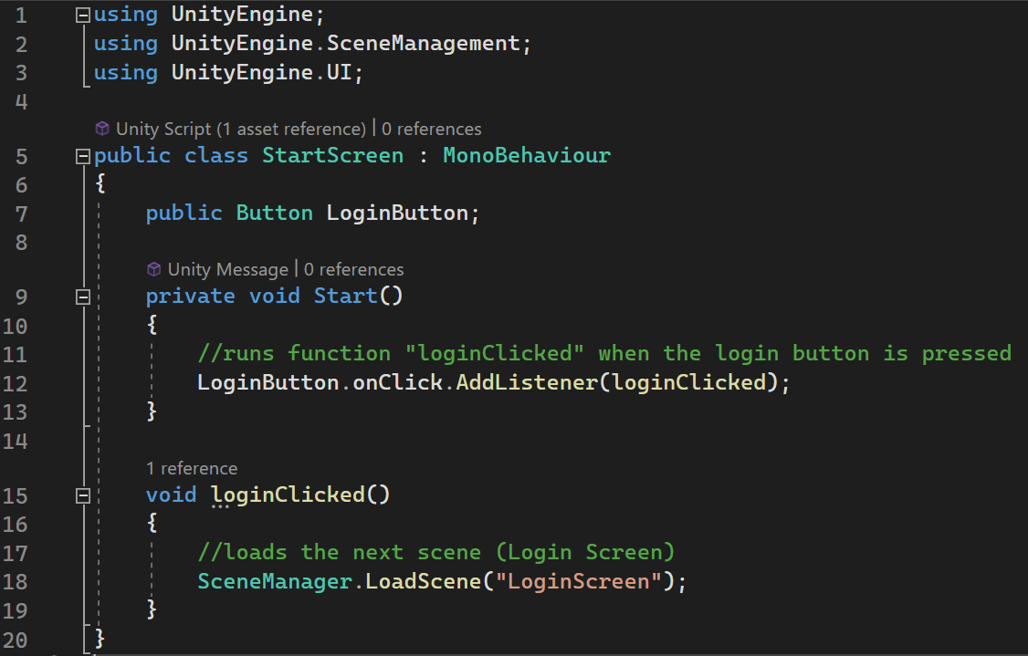



The first screen to display when the project is started is called the Start Screen. On the start screen, there is a ‘Login’ button that calls the function ‘loginClicked’. This function loads the Login Screen. The Start Screen also displays the title of the game and will have an image in the background to make it look more appealing for the user.

## Login screen

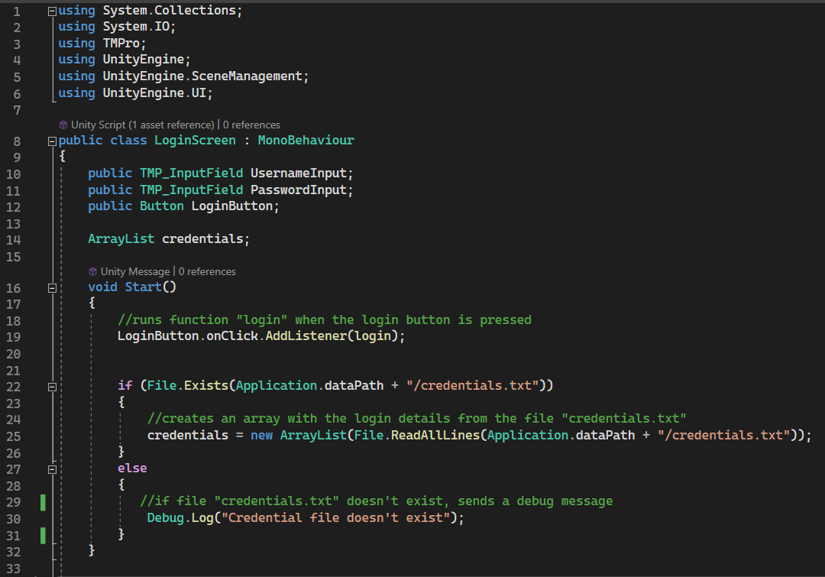

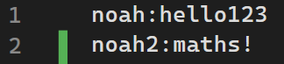For the Login screen, the script reads a text file to create an array called ‘credentials’. This allows for the teacher to easily add the login details to a file, rather than needing to edit code to add them, which helps to make the game more accessible and usable for the teachers. If the ‘credentials.txt’ file is found in the Assets, then the ‘credentials’ array will be updated with a string value for each line of the file. For example:

This credentials file would produce an array: [‘noah:hello123’, ‘noah2:maths!’]. If the file is not found, then the program will output ‘Credentials file doesn’t exist. The code highlighted in orange causes an issue as when the game is ‘built’ or compiled, the files cannot be accessed in the same way, meaning that if I want to distribute the executable game file to a school, the method of accessing this file must be changed.

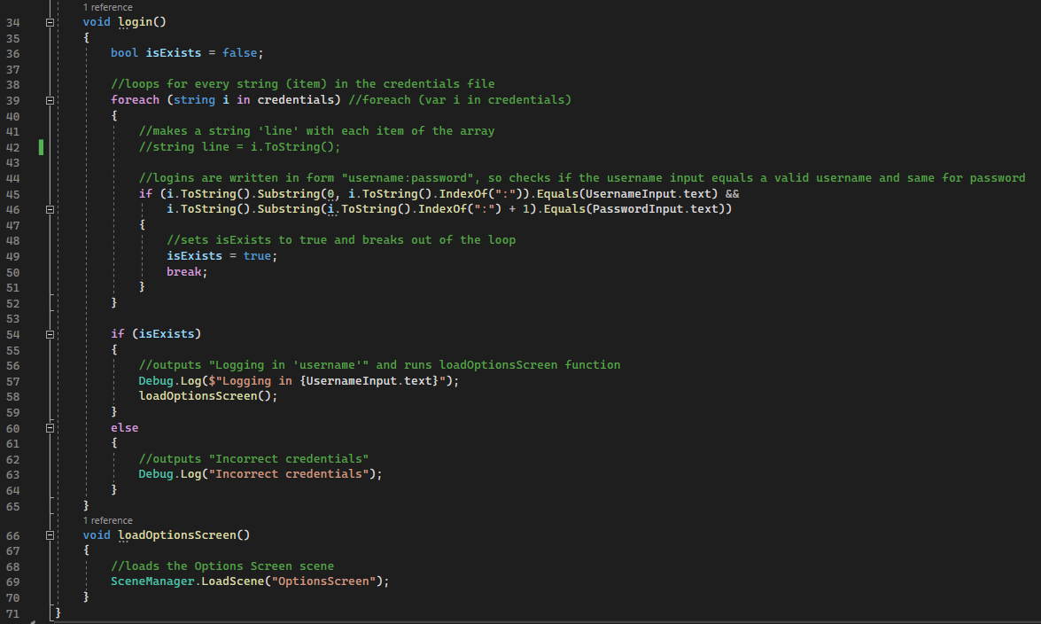

When the button is pressed, the login function is called. This function loops through each string in the ‘credentials’ array (which is each line in the credentials file) and, if the string before the ‘:’ is equal to the text in the Username input box and the string after the ‘:’ is equal to the text in the Password input box, then the boolean ‘isExists’ is set to true, and the loop is broken. Then, if ‘isExists’ is true, the Options Screen is loaded and the message ‘Logging in’ with the Username is outputted. Else, if the Username and Password inputs don’t match ant of those in the ‘credentials’ file, then the message ‘Incorrect credentials’ is outputted.

The code in the orange box could be improved as the message is outputted to the debug log, which will not be visible when the game is being run as an executable file. This could be fixed by outputting the message on the screen using the text feature in the TextMeshPro asset.

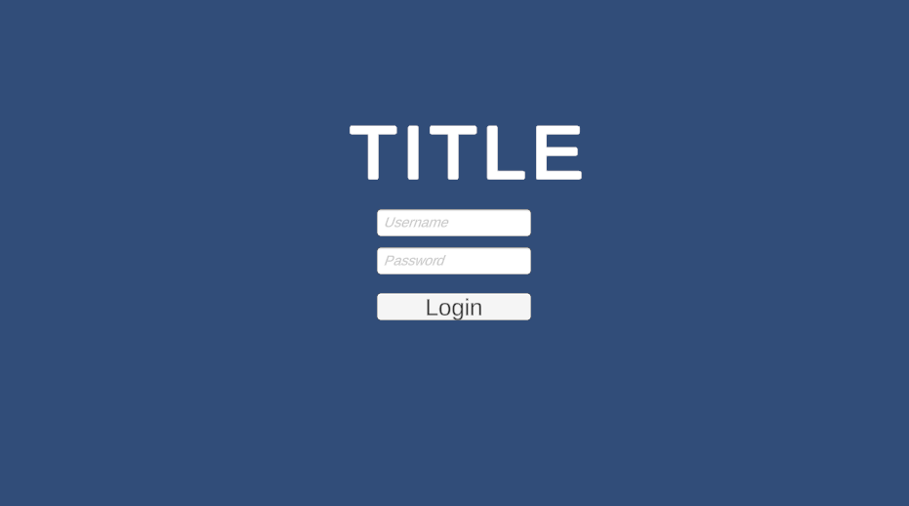

The Login screen, above, displays the title and has two input fields for the Username and Password. It also has a button to login once the two input fields have been filled. The background, like with the Start screen, will be made more appealing to the user with an image in the next iteration.

## Options screen

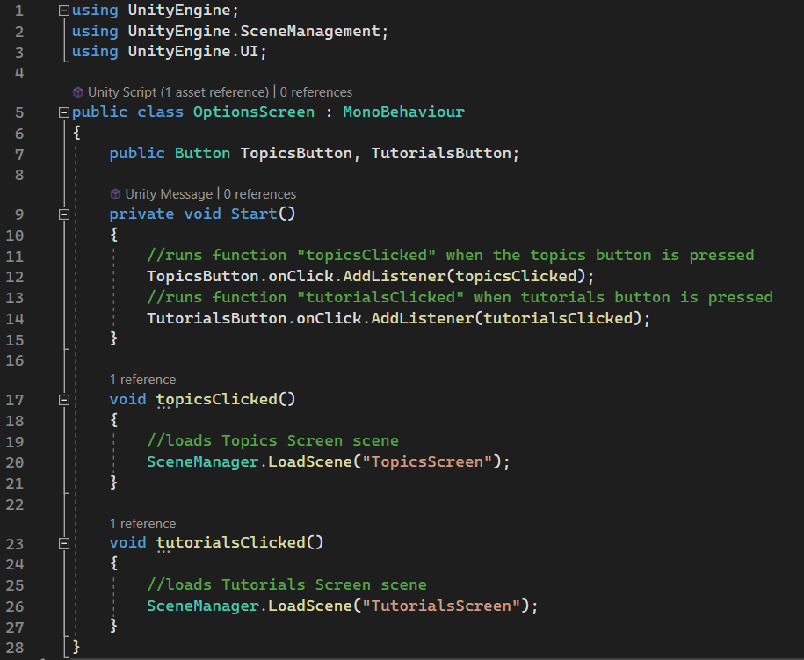

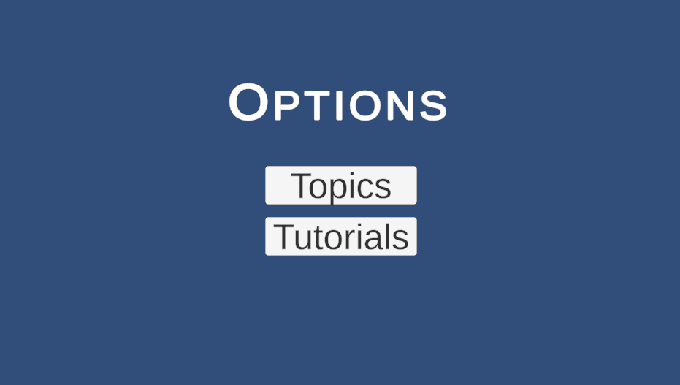

The Options screen is simple, allowing the user to choose either the ‘Topics’ or ‘Tutorials’ option, which will take them to the related screen. The code for this is simple, running the appropriate function based on the button that is pressed.

## Topics and Tutorials screens

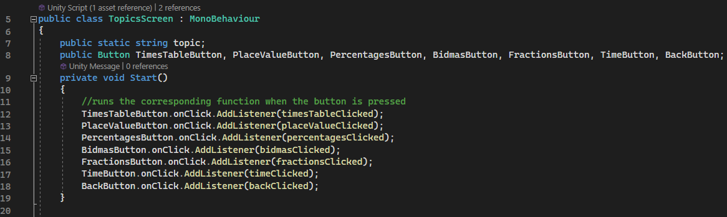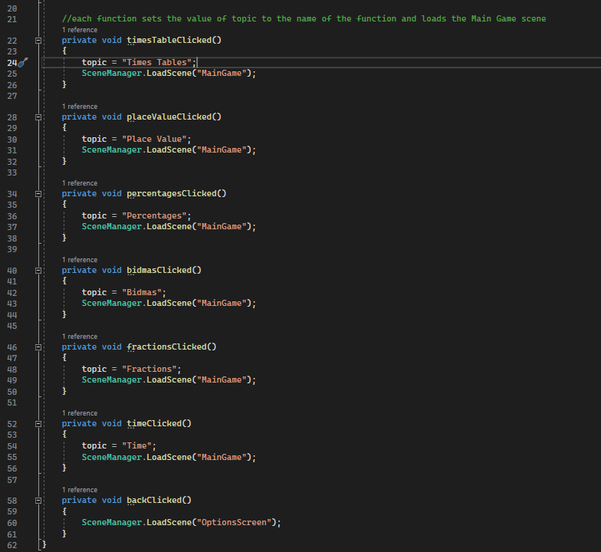

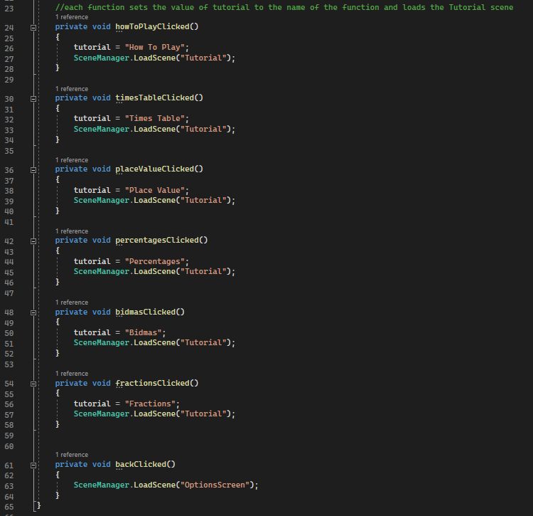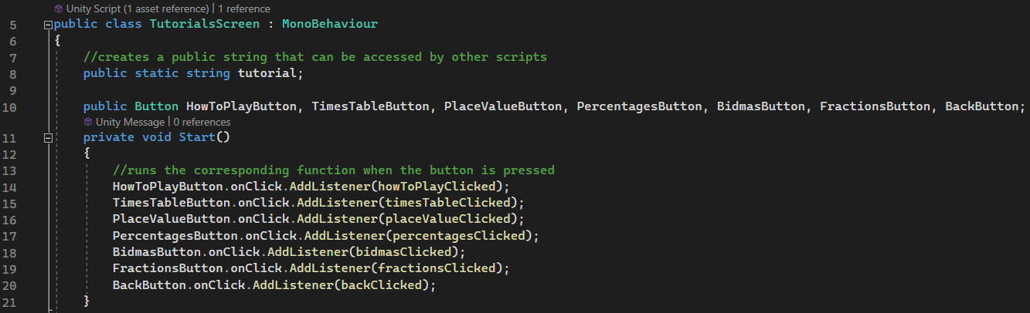

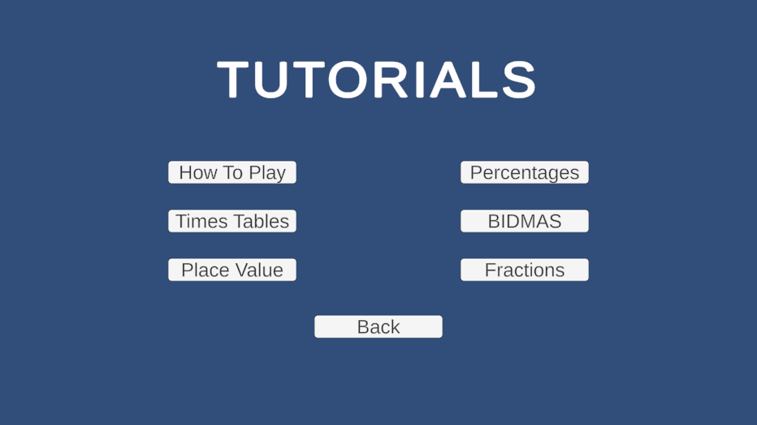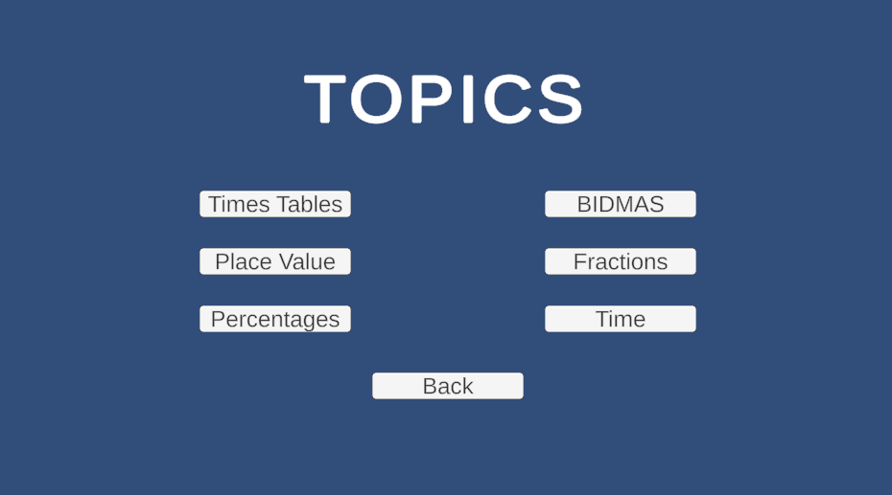

The Topics and Tutorials screens are very similar, using almost the exact same code and looking very alike. Each button calls the respective function and this function, first changes the tutorial/topic variable to the correct. The tutorial and topic variables are public, meaning that they can be accessed from different scripts. This allows the correct name to easily be displayed at the top of each screen, without needing to have a specific scene for each different topic/tutorial.

## A grey rectangular object with white text Description automatically generatedTutorials

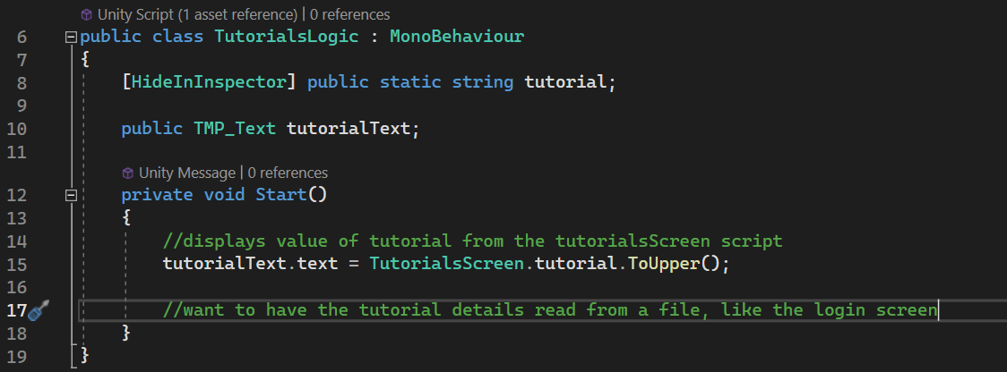Currently, the tutorial screens have very little functionality. When the button for a tutorial is pressed, the correct text will be displayed on screen but that is all that happens in this iteration. For the next iteration, I would like the tutorial screens to display the text, and maybe images, relating to the topic. The screen should also have a back button so that the user can return to the menu.

## A screenshot of a video game Description automatically generatedMain game

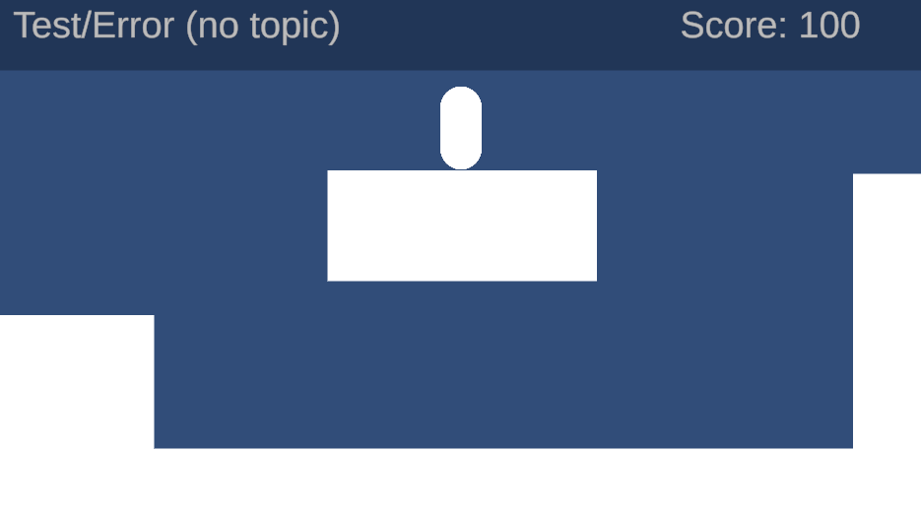

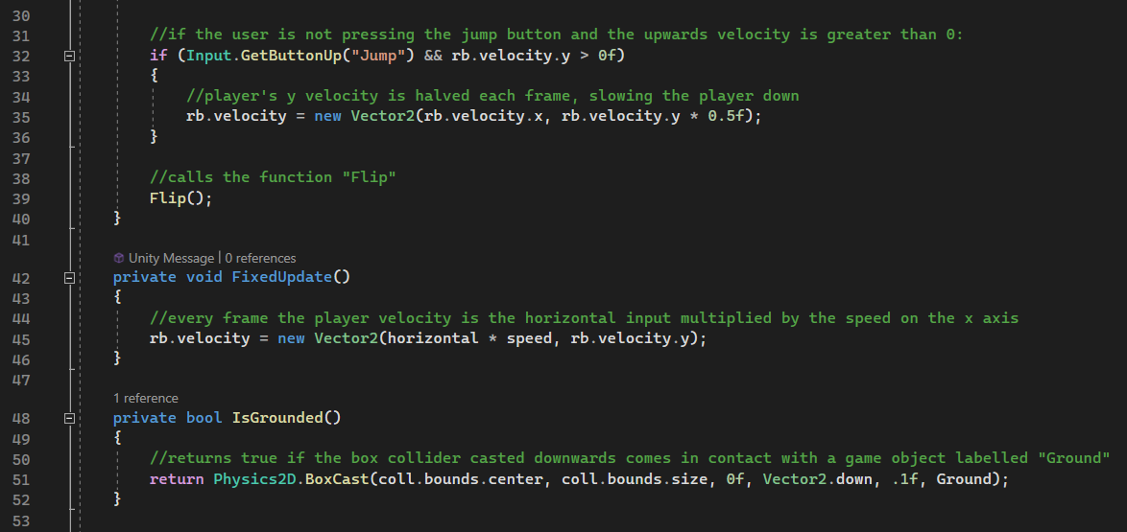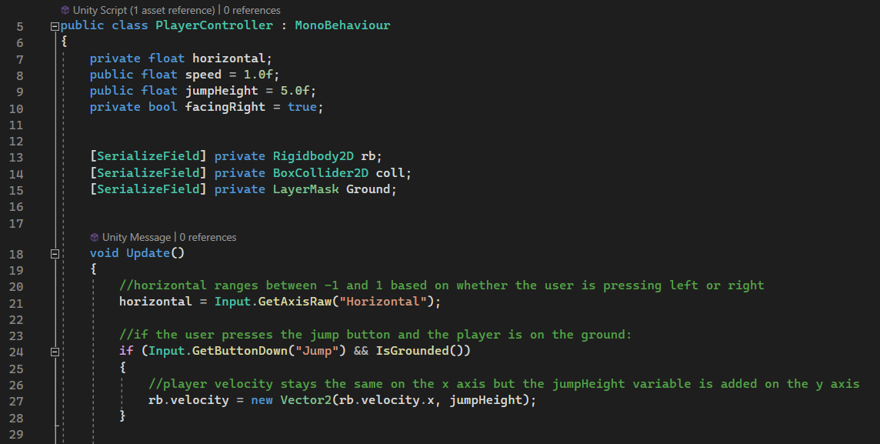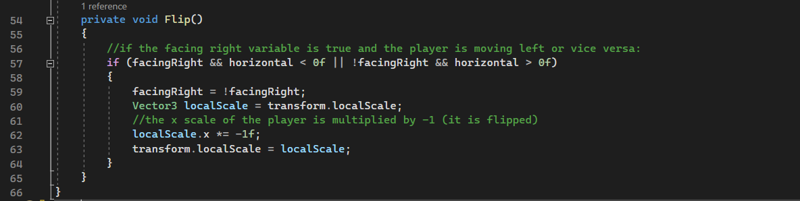

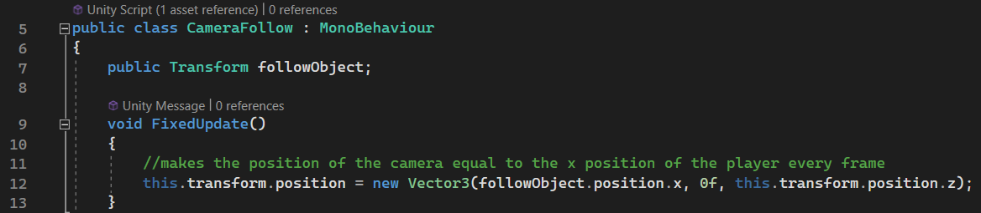The main game consists of a player that van move and jump around the environment. The environment has platforms and question areas that cause a question to appear. The above scripts are the player controller, which dictates how the player moves around the game, and the camera follow, which dictates how the camera reacts to the player’s movement. The script updates every frame, using the left and right keys to dictate the speed and direction of the player and allowing the player to jump when touching the ground. The ‘IsGrounded’ function ensures that the player can only jump when on the ground, however it results in the player not being able to move when in contact with the sides of platforms which makes it hard to jump around the environment easily. The ‘Flip’ function simply flips the player to face in the direction that they are moving in. The camera follow script simply sets the x position of the camera to the player’s x position every frame so that it stays in the middle of the screen.

## A screenshot of a computer program Description automatically generatedQuestion Spawn

The Question Spawn script allows the questions to appear when the player interacts with the question area. It ensures that if the player collides with an object that has the tag ‘Question’, then it will make the question visible and hide the other objects. It also means that if the player collides with an object with the ‘End’ tag, then it will load the Game Over screen.

## A computer screen shot of a program Description automatically generatedQuestion Logic

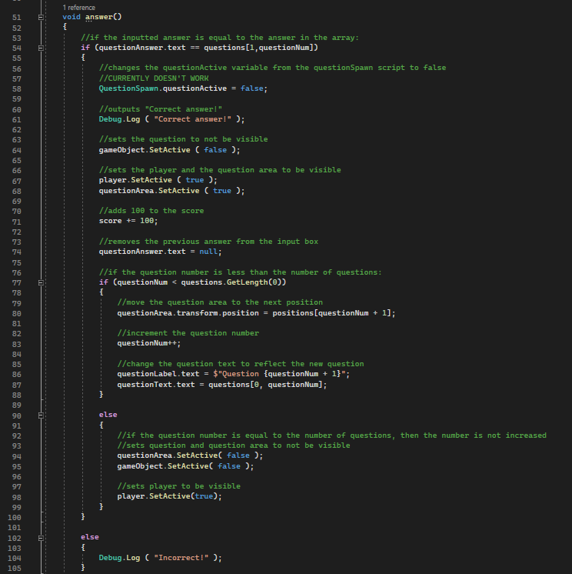

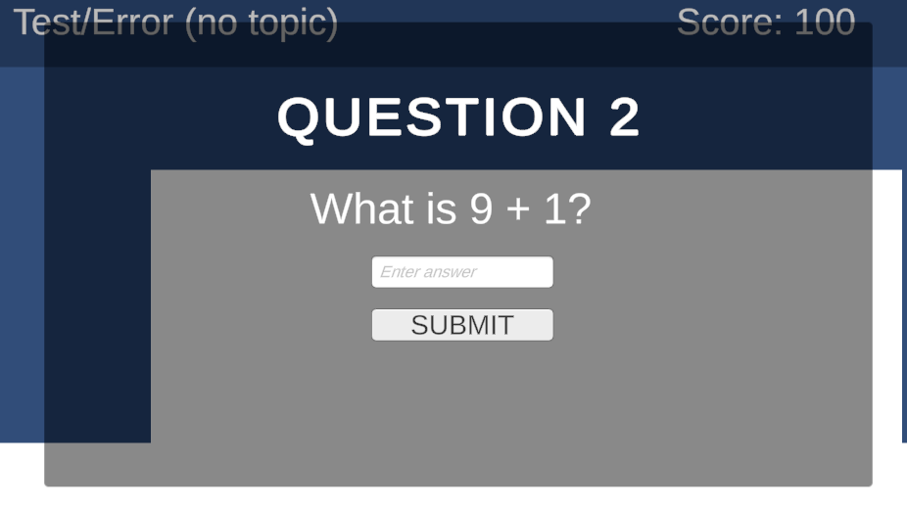

The logic for the questions allows the questions to be displayed with the correct information. It contains arrays for the positions of the questions and the actual questions and answers. The script displays the text ‘Question’ with the correct number and shows the corresponding question. It also contains an input field and a submit button. If the answer is incorrect then ‘Incorrect!’, but if the answer is correct then the score will be increased, the question area is moved to the next position, the question will be hidden, and the player will be shown again.

## Overlay Logic

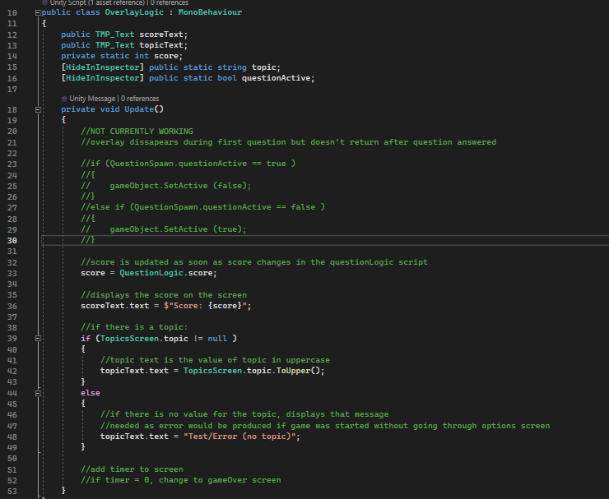

The overlay logic script controls the overlay at the top of the screen displaying the information about the game, such as the user’s score and the topic name. The overlay also needs a timer added that will display how long the user has left before the game ends. I also attempted to make the overlay disappear when a question was on the screen, but the code needs to be improved to make that work as it involves accessing and changing a variable from a different script.

## Testing

|  |  |  |
| --- | --- | --- |
| ID | Pass/Fail | Comment |
| 1 | Pass | If the user enters valid login details, then they can log into the game |
| 2 | Pass | If the user enters invalid details, then they cannot log into the game |
| 3 | Pass | If the user enters invalid details, then they cannot log into the game |
| 4 | Pass | If the user enters invalid details, then they cannot log into the game |
| 5 | Pass | If the user enters no details, then they cannot log into the game |
| 6 | Pass | If the login button is pressed with the left mouse button, then the function is called |
| 7 | Pass | If the button is clicked with the right mouse button, then the function is not called |
| 8 | Pass | If a keyboard button is pressed when hovering over the login button, then nothing happens |
| 9 | Pass | If the background is pressed, then no functions are called, and nothing happens |
| 10 | Pass | If a keyboard button is pressed when hovering over the background, then no functions are called, and nothing happens |
| 11 | Pass | If the “a” or “Left arrow” key is pressed when the user is on the ground/a platform, then the player moves to the left |
| 12 | Pass | If the “d” or “Right arrow” key is pressed when the user is on the ground/a platform, then the player moves to the right |
| 13 | Pass | If the “Space”, “w” or “Up arrow” key is pressed when the user is on the ground/a platform, then the player jumps |
| 14 | Pass | If the “a” or “Left arrow” key is pressed when the user is not on the ground/a platform, then the player moves to the left |
| 15 | Pass | If the “d” or “Right arrow” key is pressed when the user is not in contact with the ground/a platform, then the player moves to the right |
| 16 | Pass | If the “Space”, “w” or “Up arrow” key is pressed when the user is not on the ground/a platform, then the player does not jump |
| 17 | Pass | If another keyboard button is pressed, then no functions are called |
| 18 | Pass | If a mouse button is clicked, then no functions are called |
| 19 | Pass/Fail | When the user comes in contact with the question area it generates a question, however the question isn’t random |
| 20 | Pass | Questions do not appear when the user is not in contact with a question area |
| 21 | Pass | If the user enters a correct answer, then ‘Correct’ is displayed, the score is increased, and the user is returned to the main game |
| 22 | Pass | If the user enters an incorrect answer, then ‘Incorrect’ is displayed and the user can attempt the question again |
| 23 | Pass | If the user enters no answer, then nothing happens |
| 24 | Fail | There is currently no hint button |
| 25 | Fail | There is currently no hint button |
| 26 | Pass | If the user comes in contact with the end flag, then they are taken to a Game Over screen |
| 27 | Pass | If the user does not come in contact with the end flag, then nothing changes |
| 28 | Fail | There is currently no message displayed when the user finishes the game |
| 29 | Fail | There is currently no message displayed when the user finishes the game |

## Stakeholder Feedback

After showing my stakeholders the game and allowing them to play it, I received this feedback:

* + When a question appears, you should automatically be able to type into it, rather than needing to click on the input field.
  + You should also be able to press enter to submit an answer rather than having to press that button as that increases the number of key presses and makes it more difficult to play the game quickly and casually.
  + More challenging obstacles/things to avoid would be appreciated as it would make the game a lot more interesting to play.
  + The ‘question area’ could instead be an item that the user picks up which would take the player to a new scene with the question and multiple answers that the character needs to interact with to answer the question.
  + The finish could also be made so that the user can get there without answering any questions but cannot complete the game until they have collected enough items.
  + It was also suggested that that the questions could be made based on the student’s performance, creating a completely random question which could be done by using a question template and inputting random numbers or using AI to create brand new questions, perhaps integrating the ChatGPT API into Unity. This could be implemented in the future.

## Improvements for further iterations

* + Add hints to allow the user to get help when answering questions and prompt the user to use the hints when they get the question wrong.
  + Add a timer to the main game.
  + Randomise the question order or the questions.
  + Make the overlay disappear when the question is on the screen.
  + Read the text for the tutorials from a text file.
  + Create a question difficulty that can change based on number of correct/incorrect answers.
  + Have the platforms at random heights each time, creating a different environment every time the game is played.
  + Change the question area to an item that the user can interact with that moves the user to another screen with the question answers.
  + Create a login for the teachers that takes them to a different screen to the students.
  + Allow the teachers to add user logins to the credentials file when logged in.

Prototype 2

## Login screen

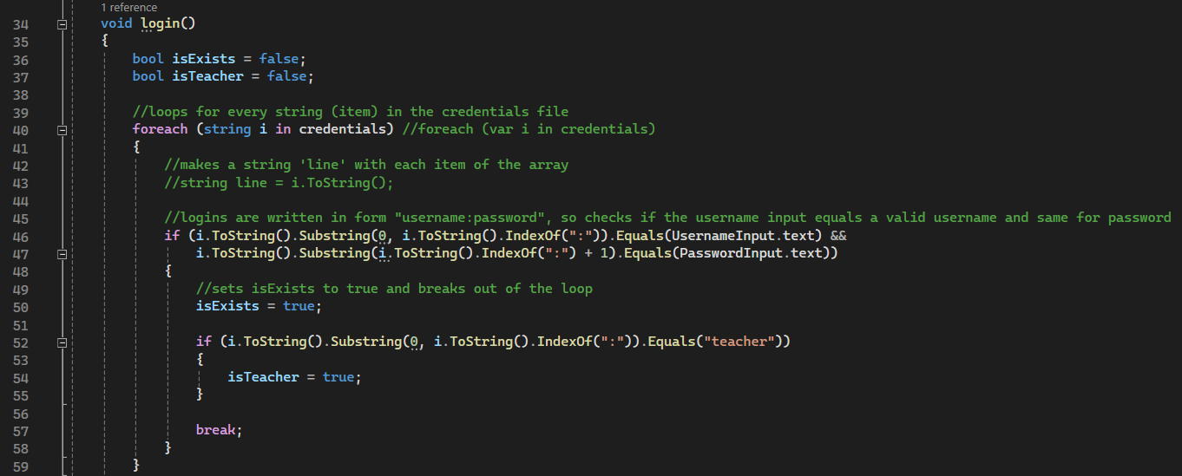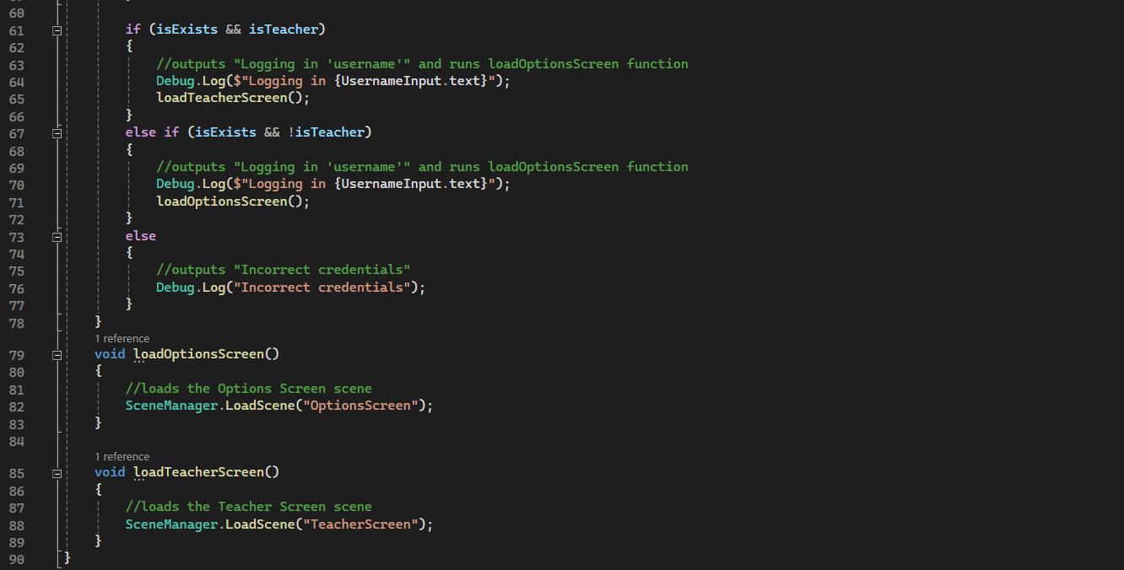

On the login screen, at the request of my stakeholders, I created a login that will take the user to the teacher screen. This allows the user to login using “teacher” as the username and it will take them to a screen specifically for teachers. Overall, the code for the login screen has been unaltered other than adding in the extra if statement containing the “isTeacher” variable.

## Teacher Screen

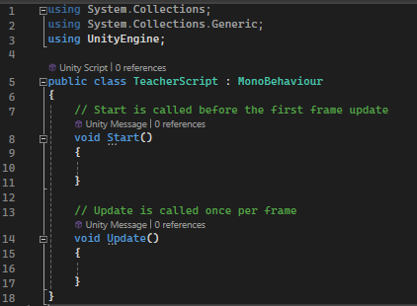

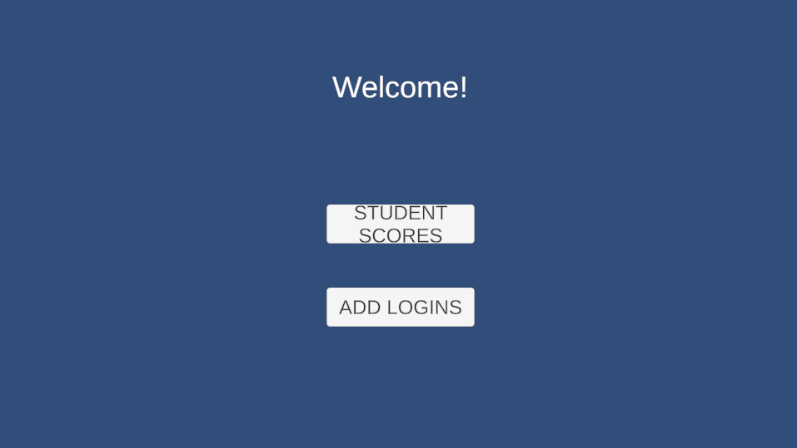

The teacher screen simply has two buttons that will allow them to see the students’ scores and add new logins for students to be included if they are going to be playing the game. At completion of the second prototype, the teacher screen has not been coded to function, but the score variable is saved when the user plays and could be stored in a text file to allow the teacher to see the students’ scores.

## Main Game – Questions & answers

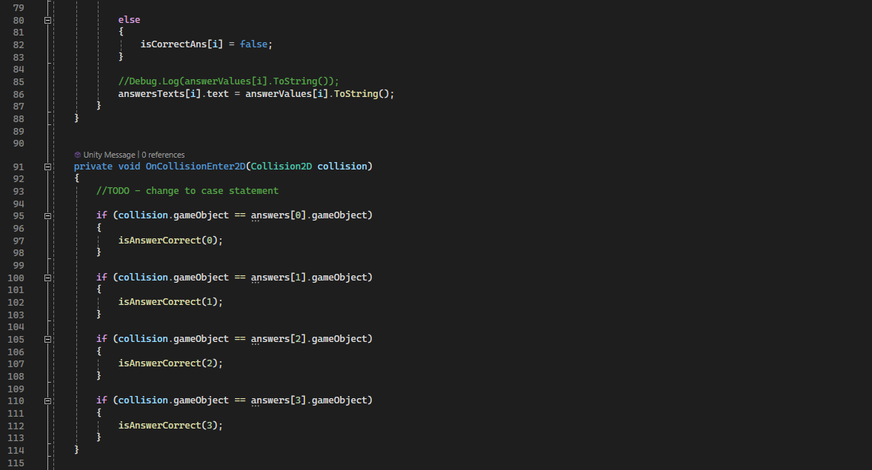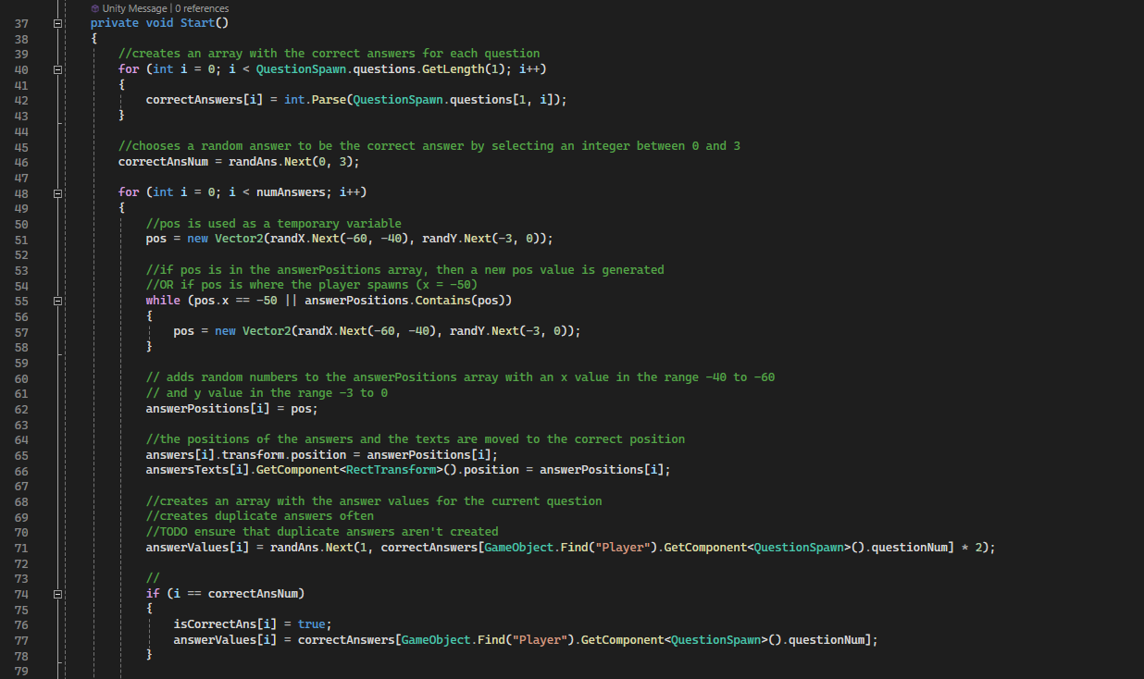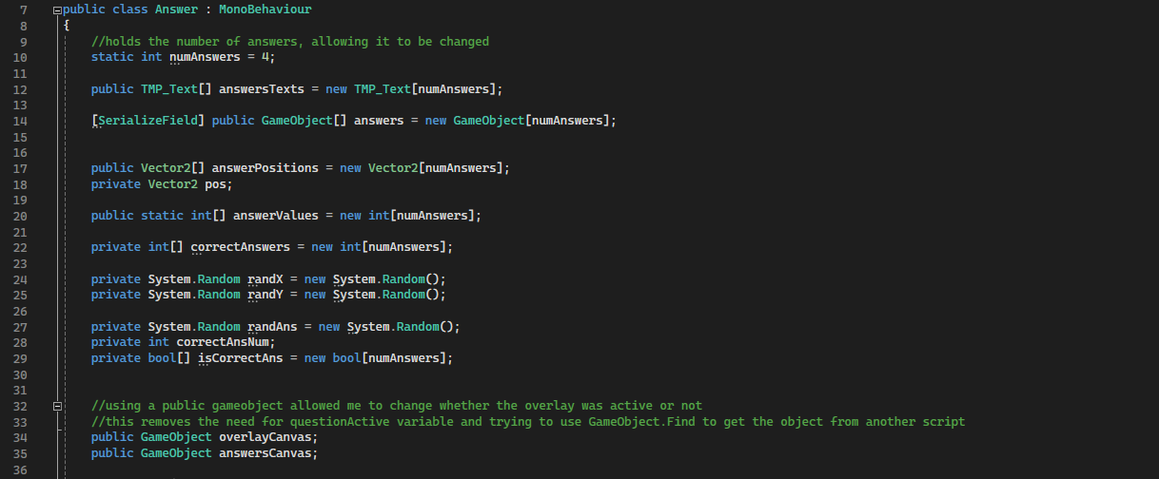

The Answer script dictates how the questions function and are answered. As requested by the stakeholders, the questions now take place on a different screen in which the user needs to touch the correct answer to continue.

When the scene is started, the correctAnswers array is populated using the questions array from the QuestionSpawn script. Then a random number is chosen to be the correctAnsNum, which is the answer object that is correct. A loop is then used to change the position of the answers, using a temporary value to ensure that questions don’t appear in the same position, which was a common problem when testing. This loop also moves the text for each answer to be at the same place as the answer object, assigning them a random value from one to twice the answer, giving a large range for the value. Finally, if the current answer that is being looped through is the correct answer object, then the answer value will be changed to the correct answer, using the question number.



When the user collides with an answer, an if statement works out which answer object was collided with and runs the isAnswerCorrect function with the value corresponding to the object. This could be changed to a switch/case statement to allow the function to run quicker.

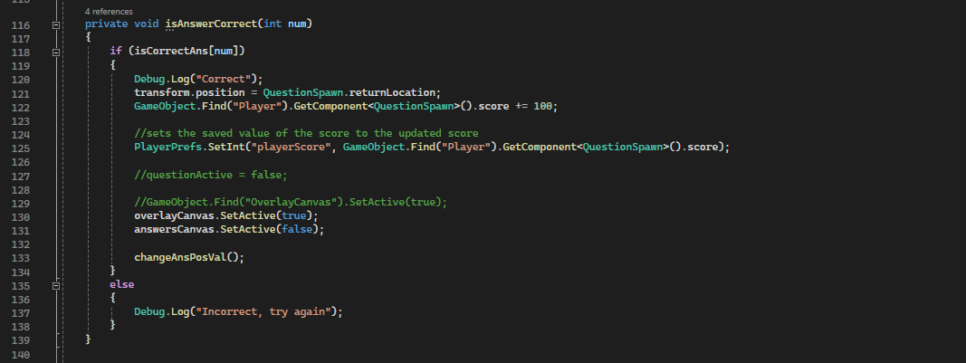The isAnswerCorrect function simply works out if the answer is correct or not and responds accordingly. The function takes in an integer (num) that is used to check if the answer is correct. The isCorrectAns array contains true in the index that is the correct answer, so will return true if the integer num is the number of the correct answer. It also saves the player score using the Unity PlayerPrefs class which can store integer, float or string values, to allow the value to be accessed in other scenes, such as the game over screen. The function then sets the overlayCanvas to be active and the answersCanvas to no longer be active and then runs the changeAnsPosVal function. However, if the answer is not correct, then it outputs “Incorrect, try again”.

The changeAnsPosVal function, which changes the position and value of the answers. The function performs the same processes as are used at the start of the scene to set the positions and values of the answers, however, does not include the initialisation of the arrays. This means that the start code could probably be replaced with this function to make it simpler.

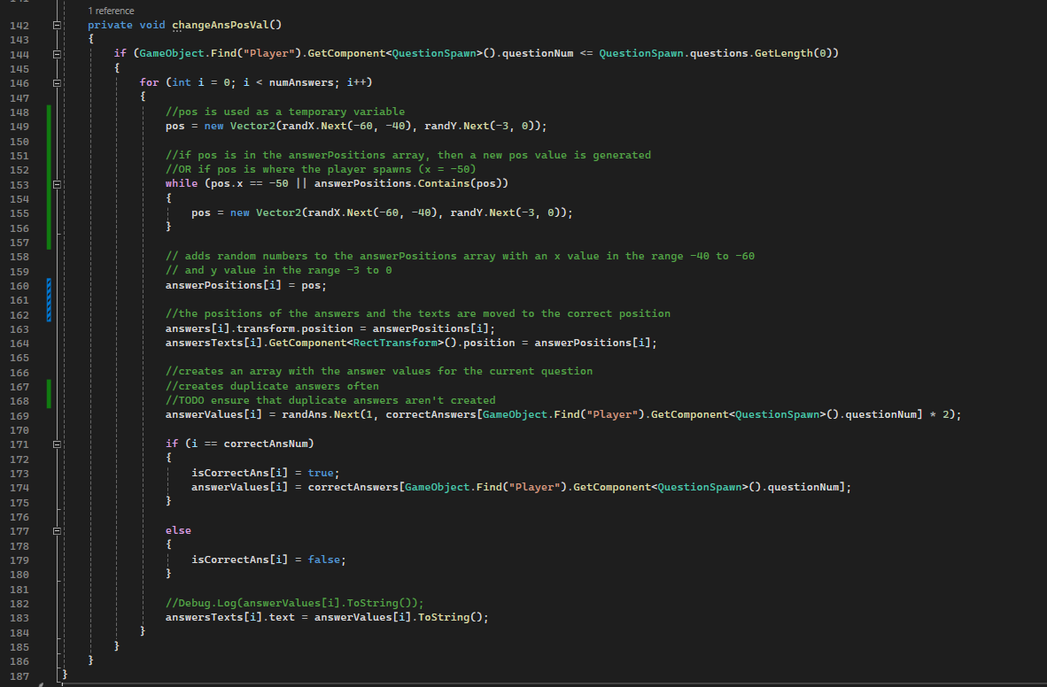

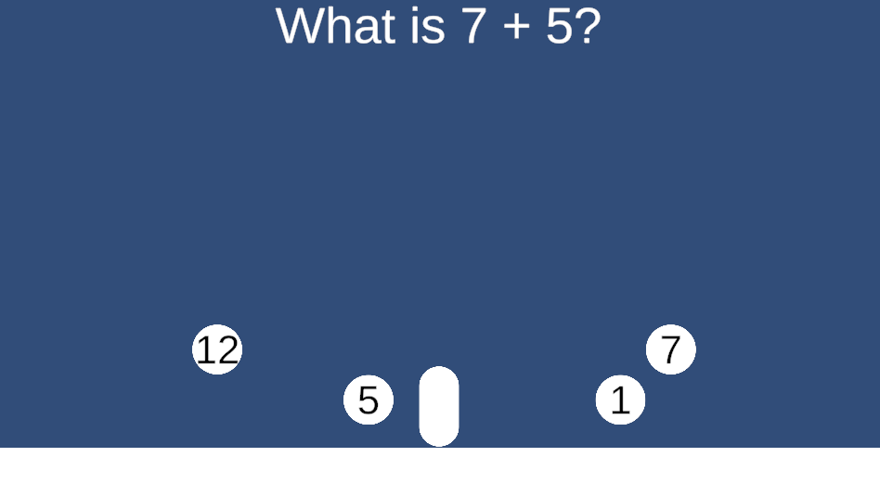

The above screenshot shows the answer objects and the question area. The question area has not platforms or environments, but these could easily be added, along with tweaking the positions that the questions will spawn in to add more interest to this area as it is currently very bland and uninteresting.

## Question Spawn

The Question Spawn script has been changed to reflect the new question mechanics. Instead of simply causing the question to show on the screen, it is now responsible for moving the user to the question area. When moving the user to the question area, it stores the current location of the player as returnLocation so that the user can be returned to the exact location that they left from. The update function is also used to ensure that the text for the question area stays in the middle at the top of the player’s screen while they move.

## A computer screen shot of a program Description automatically generatedGame Over Screen

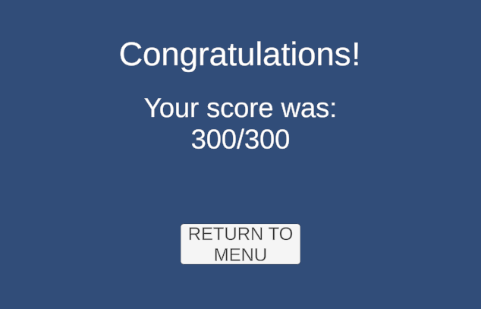

The Game Over screen now functions as required, displaying the score that the user achieved and a corresponding message. The game over screen uses the PlayerPrefs class to now get the value of playerScore that was previously saved during the main game. This makes it much easier to access the variable, as opposed to attempting to reference another script and find the variable in it. Currently, since there are only 3 questions, the max score is 300, however, this will need to be changed to match the number of questions when more questions are added to the game. The game over script uses a simple if else statement to output a message based on the score. The screen now also contains a back button so that the user can return to the menu screens after finishing a level.

## Tutorials

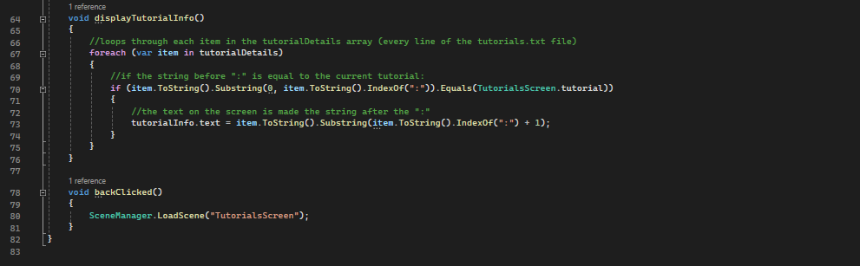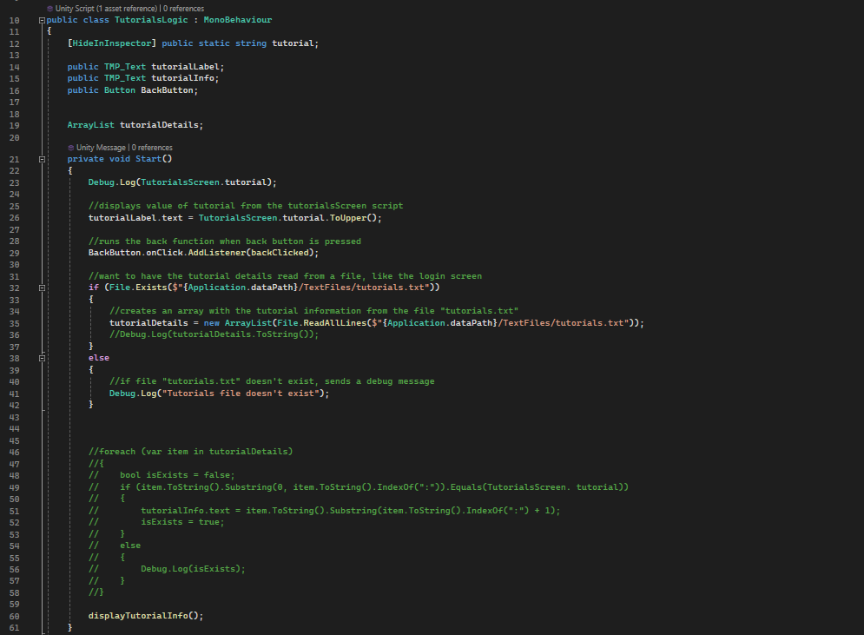

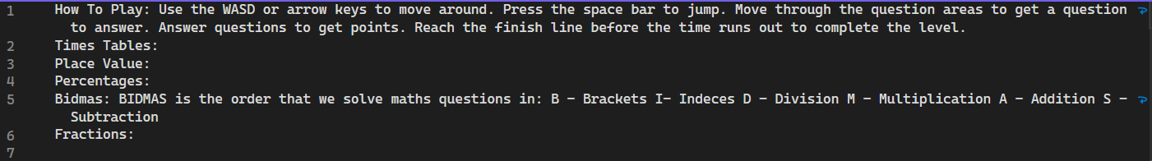

The tutorials screen has a label followed by details. The label text simply uses the tutorial variable assigned on the TutorialsScreen, however the details are added from a text file. This works in a very similar way to the login method, creating an array from the text file and using that to access the data. To display the information, the displayTutorialInfo function loops through each item in the array and, if the text before the colon matches the current tutorial, then it sets the text to be the saved description. As shown above in the screenshot of the text file, this means that the file must be set out correctly to avoid errors.

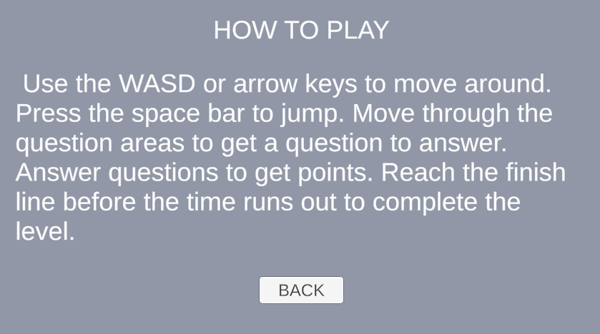

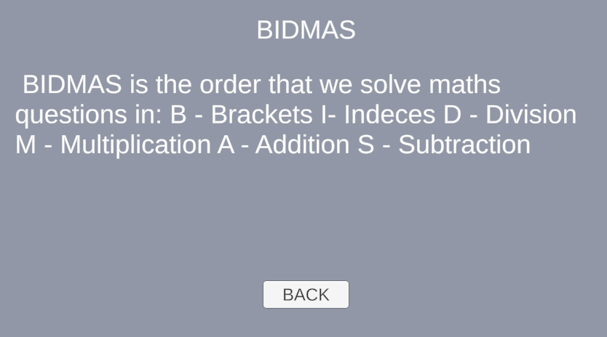

However, as demonstrated in the above screenshots, this approach has its drawbacks. Using a text file in this way adds each line of the file as a separate item in the array, meaning that the description must be written on a single page. This makes the formatting a lot harder as the string would then need to be split up and placed on different lines, which is currently not possible.

## Testing

|  |  |  |
| --- | --- | --- |
| ID | Pass/Fail | Comment |
| 1 | Pass | If the user enters valid login details, then they can log into the game |
| 2 | Pass | If the user enters invalid details, then they cannot log into the game |
| 3 | Pass | If the user enters invalid details, then they cannot log into the game |
| 4 | Pass | If the user enters invalid details, then they cannot log into the game |
| 5 | Pass | If the user enters no details, then they cannot log into the game |
| 6 | Pass | If the login button is pressed with the left mouse button, then the function is called |
| 7 | Pass | If the button is clicked with the right mouse button, then the function is not called |
| 8 | Pass | If a keyboard button is pressed when hovering over the login button, then nothing happens |
| 9 | Pass | If the background is pressed, then no functions are called, and nothing happens |
| 10 | Pass | If a keyboard button is pressed when hovering over the background, then no functions are called, and nothing happens |
| 11 | Pass | If the “a” or “Left arrow” key is pressed when the user is on the ground/a platform, then the player moves to the left |
| 12 | Pass | If the “d” or “Right arrow” key is pressed when the user is on the ground/a platform, then the player moves to the right |
| 13 | Pass | If the “Space”, “w” or “Up arrow” key is pressed when the user is on the ground/a platform, then the player jumps |
| 14 | Pass | If the “a” or “Left arrow” key is pressed when the user is not on the ground/a platform, then the player moves to the left |
| 15 | Pass | If the “d” or “Right arrow” key is pressed when the user is not in contact with the ground/a platform, then the player moves to the right |
| 16 | Pass | If the “Space”, “w” or “Up arrow” key is pressed when the user is not on the ground/a platform, then the player does not jump |
| 17 | Pass | If another keyboard button is pressed, then no functions are called |
| 18 | Pass | If a mouse button is clicked, then no functions are called |
| 19 | Pass/Fail | When the user comes in contact with the question area it generates a question, however the question isn’t random |
| 20 | Pass | Questions do not appear when the user is not in contact with a question area |
| 21 | Pass | If the user enters a correct answer, then ‘Correct’ is displayed, the score is increased, and the user is returned to the main game |
| 22 | Pass | If the user enters an incorrect answer, then ‘Incorrect’ is displayed and the user can attempt the question again |
| 23 | Pass | If the user enters no answer, then nothing happens |
| 24 | Fail | There is currently no hint button |
| 25 | Fail | There is currently no hint button |
| 26 | Pass | If the user comes in contact with the end flag, then they are taken to a Game Over screen |
| 27 | Pass | If the user does not come in contact with the end flag, then nothing changes |
| 28 | Pass | If the user gets 100% then “Congratulations” is displayed for the user |
| 29 | Pass | If the user gets less than 100 points, then there is a message displayed saying “Unlucky, try again” |

## Improvements from previous iteration

* Added the tutorial screen, which displays tutorial information based on the chosen topic.
* Read the tutorials from a text file to allow for multiple tutorials to be saved.
* Changed the way in which questions are answered to make the game more interactive and interesting to the user.
* Add a teacher login that will allow features to be added for the teacher in the next iteration, such as adding logins and viewing student scores.
* Made the overlay disappear when on the question screen so that the question can be displayed.

## Stakeholder Feedback

* It would make the user experience much smoother to be able to press enter to login rather than needing to press the login button.
* Making the game more interactive would ensure that the players stay interested, such as adding hints if the user chooses the incorrect answer and giving less points if the answer is incorrect.
* Add a timer to the main game and take away time if the answer is incorrect, for example, giving the user 3 minutes to complete the level but taking away 10 seconds if the user guesses the answer incorrectly.
* The number of points could be based on the speed that the user finishes the level, so the quicker the level is finished, the more points the user gets, promoting the students to answer questions more quickly. If the timer runs out, then the game ends and the user gets no points.

## Improvements for final iteration

**From current iteration feedback:**

* + Allow the user to press enter to move through the login screen.
  + Add hints when the user gives an incorrect answer, to allow them to learn from mistakes.
  + Add features to the teacher screen (display score and add login details)
  + Add a timer to the main game that decreases when an incorrect answer is chosen.
  + Assign user points based on the speed that they finished the game.
  + Display the time that the user took to complete the level and how many points that corresponds to.
  + Read questions from a text file so that more questions can be added and differentiated by topic.

**From previous iteration feedback:**

* Randomise question order.
* Have platforms appear at random places in the scene.
* Change ‘question area’ to an item that the user can collect.

Prototype 3

## A screen shot of a computer Description automatically generatedA computer screen shot of a program code Description automatically generatedMenu Inputs

The script allows the user to navigate the menu screens, such as the Login screen, by pressing the keyboard buttons, such as the tab and enter. This ensures that moving through the menus is easy and efficient for the user as it is the same as almost all user interfaces that are commonly used to login or add details.

## Teacher screen

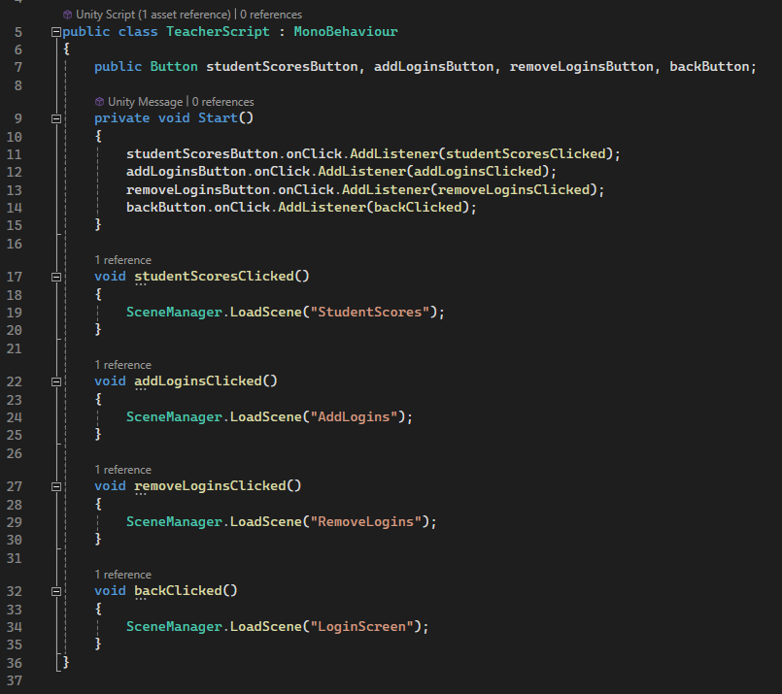

The buttons on the teacher screen will now take the user to the relevant screen when pressed. These buttons allow the user to see the students’ scores, add or remove user logins and return to the login screen to be able to play the game if needed.

## Student Scores

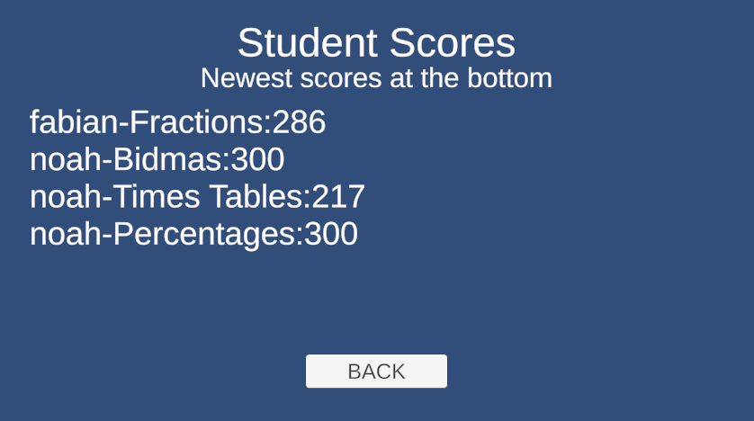

## Add logins

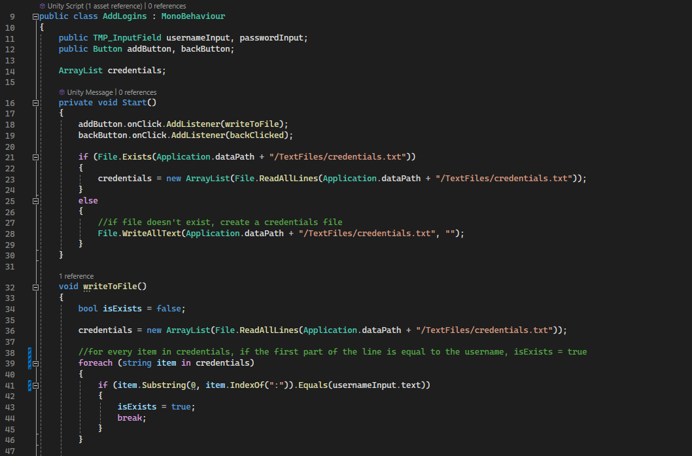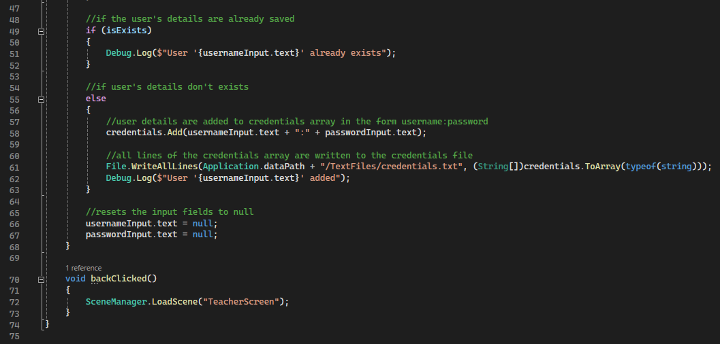

## A screenshot of a login screen Description automatically generatedRemove logins

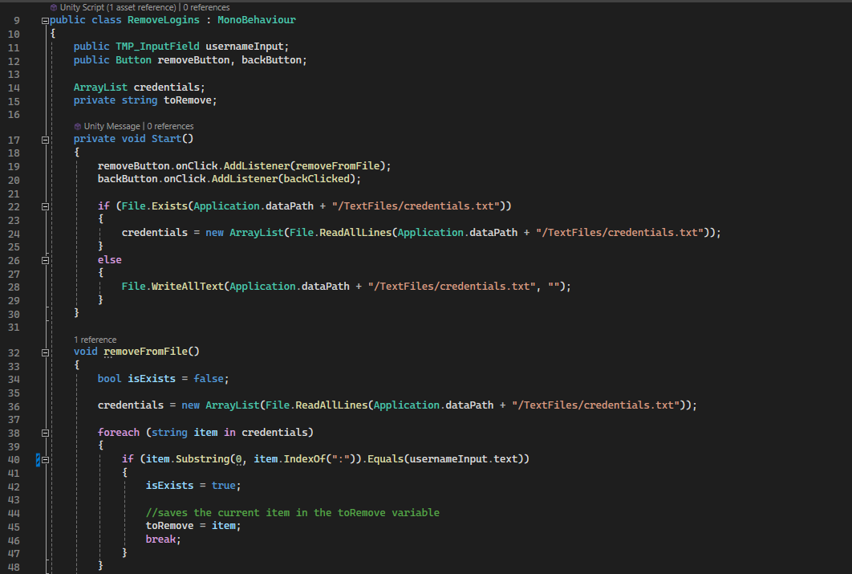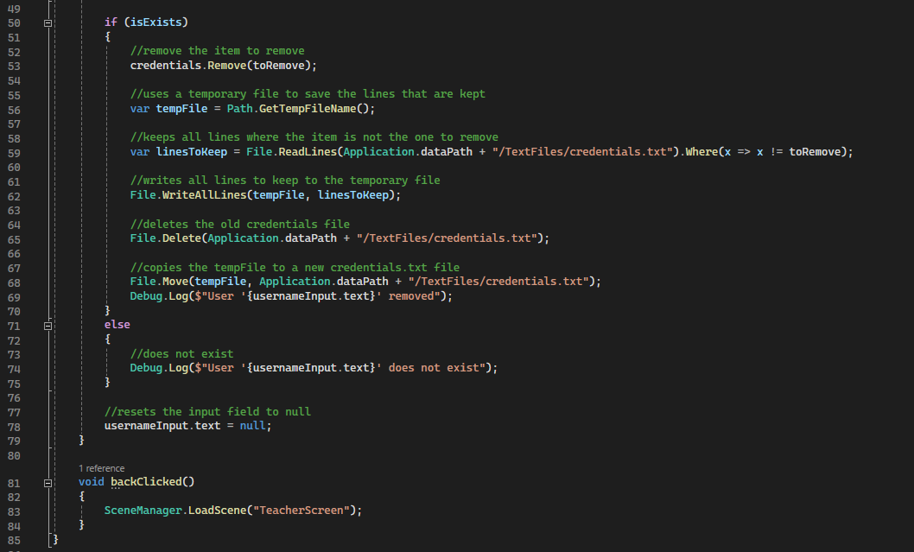

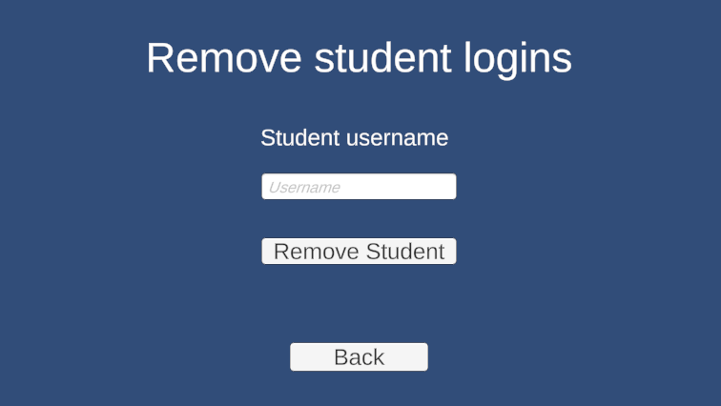

## Question spawn script

## Answer script

## Overlay logic script

# D. Evaluation

<See H446-03 Project Advice Booklet for help and guidance of what must go here.>

# Project Appendixes

Insert as many project appendixes as you need for your project.

These might include, but are not limited to:

* Complete Code Listing (ESSENTIAL)
* Interview Transcripts
* Meeting notes
* Observation notes or questionnaires

Initial paper screen designs

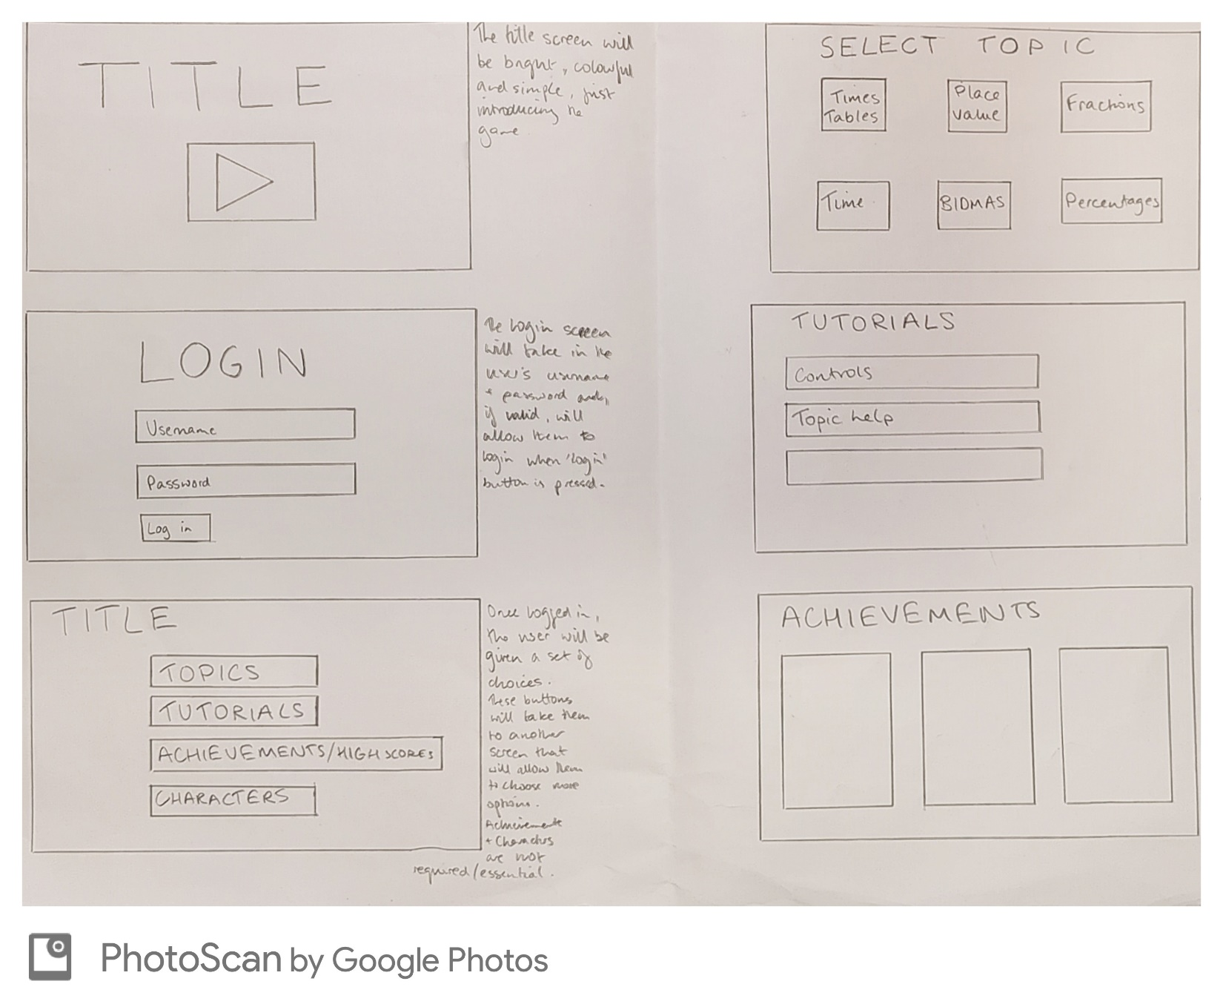

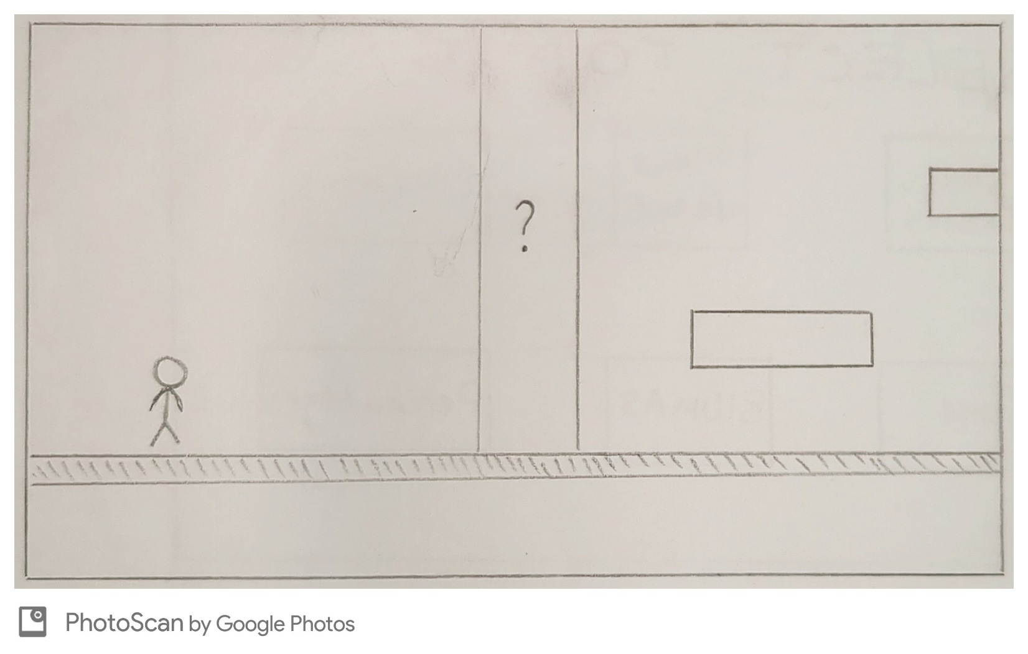

# Bibliography

|  |  |
| --- | --- |
| What | Where |
| Times Table Duck | [https//www.timestables.co.uk/times-table-duck.html](https://www.timestables.co.uk/times-table-duck.html) |
| Hit the Button | [https//www.topmarks.co.uk/maths-games/hit-the-button](https://www.topmarks.co.uk/maths-games/hit-the-button) |
| Super Mario Bros. | <https://www.mariowiki.com/Super_Mario_Bros>. |
| Samsung Chrome Book 4 specification | <https://www.samsung.com/uk> |
| Unity required specifications | [https://docs.unity3d.com](https://docs.unity3d.com/) |
| Screen design background | <https://nl.freepik.com/> |